

S
-
403

Published by t
he

on
International Hydrographic Organizati

1
b quai Antoine
4
er

aco
Principauté de Mon

00
Tel: (377) 93.10.81.

Fax: (377) 93.10.81
.40

.int
info@iho

www.iho
.
int

S
-
Data Product
403
Interoperability in S-100 Inland

Navigation Systems

Interoperability

Specification

Edition

.

–

Permission number 11/2026
Material from IHO publication S-98 S-100 ECDIS and Interoperability Specification Edition 2.0.0 – October 2025 is reproduced with the permission of the IHO Secretariat (Permission No 11/2026) acting for the International Hydrographic Organization (IHO), which does not accept responsibility for the correctness of the material as reproduced: in case of doubt, the IHO’s authentic text shall prevail. The incorporation of material sourced from IHO shall not be construed as constituting an endorsement by IHO of this product.

Contents
- Overview .................................................................................................................................... 1
  - Introduction ................................................................................................................................. 1
  - Scope ......................................................................................................................................... 1
  - References ................................................................................................................................. 1
  - Terms, definitions and abbreviations ......................................................................................... 2
    - Terms and definitions ................................................................................................................. 2
    - Abbreviations.............................................................................................................................. 4
  - Use of language ......................................................................................................................... 5
  - General data product description ............................................................................................... 5
  - Specification metadata ............................................................................................................... 6
  - IHO Specification maintenance .................................................................................................. 6
    - Introduction ................................................................................................................................. 6
    - New Edition ................................................................................................................................ 6
    - Revisions .................................................................................................................................... 6 1.8.4 Clarifications ............................................................................................................................... 7
1.8.5 Version numbers ........................................................................................................................ 7
  - Implementation phases (informative) ......................................................................................... 7
  - How to read and implement this specification ............................................................................ 7 2 Annex Scope .............................................................................................................................. 7
2.1 Conformance levels ................................................................................................................... 8
3 Interoperability Catalogue Identification ..................................................................................... 8 4 Data Content and Structure ....................................................................................................... 9
4.1 Application Schema ................................................................................................................... 9
4.1.1 List of covered data products ................................................................................................... 10 4.2 Interoperability Catalogue ........................................................................................................ 10
4.2.1 Introduction ............................................................................................................................... 10
iii
4.2.2 Use of S-100 types ................................................................................................................... 10
4.3 Filters ........................................................................................................................................ 11
4.4 Interoperability Levels .............................................................................................................. 12
4.4.1 Level 0 – Overlays – no explicit interoperability ....................................................................... 12
4.4.2 Level 1 – Interleaving ............................................................................................................... 12
4.4.3 Level 2 – Type-based selectivity and feature class replacement ............................................ 12
4.4.4 Level 3 – Feature hybridization ................................................................................................ 13
4.4.5 Level 4 – Spatial operations ..................................................................................................... 13
4.4.6 Progression of interoperability levels ....................................................................................... 13
5 Coordinate Reference Systems (CRS) .................................................................................... 14 6 Data Quality ............................................................................................................................. 14
6.1 Quality of displayed data .......................................................................................................... 14
6.2 Quality of Interoperability Catalogues ...................................................................................... 14 6.2.1 Test methods............................................................................................................................ 17
6.2.2 Data quality testing and reporting ............................................................................................ 17
7 Performance Standards for ECDIS .......................................................................................... 17 8 How to Make Product Specifications Interoperable ................................................................. 17
8.1 Duplicated features .................................................................................................................. 18
8.1.1 Duplicated features same model.............................................................................................. 18 8.1.2 Duplicated features, different models ...................................................................................... 18 8.1.3 Duplicate feature domains ....................................................................................................... 18
8.2 Geometry .................................................................................................................................. 19
8.2.1 Combined geometry ................................................................................................................. 19 8.2.2 Spatial discrepancy, unrelated to scaled or cartographic smoothing....................................... 19 8.2.3 Spatial discrepancies, related to scale or cartographic smoothing .......................................... 20
8.3 Display of text ........................................................................................................................... 20
8.4 Skin-of-the-earth feature operations ........................................................................................ 20
8.4.1 Skin-of-the-earth feature replacement ..................................................................................... 20
8.4.2 Skin-of-the-earth feature adjusting ...........................................................................................20
8.5 Blended feature concepts ........................................................................................................ 21
8.6 Hierarchy of data ...................................................................................................................... 21 8.7 New datasets............................................................................................................................ 21
8.7.1 New datasets - coverages ........................................................................................................ 21
8.7.2 New datasets - maximum and minimum display scales .......................................................... 21
8.7.3 New datasets - feature geometry ............................................................................................. 21 8.7.4 New datasets - types and attributes ......................................................................................... 21
8.8 Dataset scales, loading and unloading .................................................................................... 22
8.9 Metadata .................................................................................................................................. 22 8.9.1 Meta-features ........................................................................................................................... 22
8.9.2 Quality considerations .............................................................................................................. 22
- Maintenance ............................................................................................................................. 22
  - Maintenance and update frequency ......................................................................................... 22
  - Typical sources of change ....................................................................................................... 22
  - Production process .................................................................................................................. 23
  - Management of Feature Catalogue and Portrayal Catalogue updates ................................... 23 9.5 Product Specification updates other than FC/PC .................................................................... 24
  - Unpredictable Product Specification updates .......................................................................... 24
  - New data products ................................................................................................................... 24
  - Backward compatibility ............................................................................................................. 25 10 Portrayal ................................................................................................................................... 25
  - Display of significant features .................................................................................................. 25
  - Display of significant features - switching to original................................................................ 26
  - Portrayal distinguishability - colour set-asides ......................................................................... 26
  - Day/night/dusk modes .............................................................................................................. 26
  - Impacts on viewing groups ....................................................................................................... 26
  - Impacts on Portrayal Catalogues ............................................................................................. 26
  - Meta-features ........................................................................................................................... 26
    - Data quality for individual products .......................................................................................... 27
    - Portrayal of data quality for combinations ................................................................................ 27
  - Display of text ........................................................................................................................... 27
  - Skin-of-the-earth operations and portrayal .............................................................................. 27
  - Blended portrayals ................................................................................................................... 27
  - Hierarchy of data ...................................................................................................................... 27
10.11.1 Interacting gridded information................................................................................................. 28
10.12 Pick Reports ............................................................................................................................. 28
10.12.1 Combined Pick Reports ........................................................................................................... 28 10.12.2 Prioritized Pick Reports ............................................................................................................ 28 10.12.3 Full information availability ....................................................................................................... 29 10.13 User control over loaded set .................................................................................................... 29
10.14 User control over Interoperation Level ..................................................................................... 29
11 Data Product Format (Encoding) ............................................................................................. 29 12 Data Product Delivery .............................................................................................................. 30
12.1 Introduction ............................................................................................................................... 30
12.1.1 Interoperability Catalogue in different formats ......................................................................... 31
12.1.2 Extending the Interoperability Catalogue ................................................................................. 31
12.1.3 Customization - OEM/integrator ............................................................................................... 31
12.2 Interoperability Catalogue product ........................................................................................... 31
12.2.1 Interoperability Catalogue size ................................................................................................. 31
12.2.2 Interoperability Catalogue Exchange Set compression ........................................................... 31
12.2.3 Interoperability Catalogue file naming ...................................................................................... 31
12.3 Support files ............................................................................................................................. 31
12.3.1 Support file naming .................................................................................................................. 32
12.3.2 Support file management ......................................................................................................... 32 12.4 Exchange Catalogue ................................................................................................................ 32 12.5 Encryption and authentication .................................................................................................. 32
12.5.1 Encryption method ................................................................................................................... 32
12.5.2 Digital signature .......................................................................................................................32
12.5.3 Authentication and integrity checks ......................................................................................... 32
12.6 Updating the Interoperability Catalogue ................................................................................... 33
12.6.1 Updating the Interoperability Catalogue ................................................................................... 33
12.6.2 Cancelling a version of the Interoperability Catalogue ............................................................ 33
12.6.3 Updating the Interoperability Catalogue support files .............................................................. 33 13 Metadata .................................................................................................................................. 34
13.1 Introduction ............................................................................................................................... 34
13.2 Language ................................................................................................................................. 34
13.3 Interoperability Catalogue Metadata elements ........................................................................ 34
13.3.1 S100_ExchangeCatalogue ...................................................................................................... 37
13.3.2 S100_ExchangeCatalogueIdentifier ........................................................................................ 38
13.3.3 S100_CataloguePointofContact ............................................................................................... 38
13.3.4 S100_Purpose.......................................................................................................................... 39
13.3.5 S100_ProductSpecification ...................................................................................................... 39
13.3.6 S100_ProtectionScheme ......................................................................................................... 40
13.3.7 S100_SupportFileDiscoveryMetadata ..................................................................................... 40 13.3.8 S100_SupportFileFormat ......................................................................................................... 41
13.3.9 S100_SupportFileRevisionStatus ............................................................................................ 42
13.3.10 S100_SupportFileSpecification ................................................................................................ 42
13.3.11 S100_ResourcePurpose .......................................................................................................... 42
13.3.12 S100_CatalogueDiscoveryMetadata ....................................................................................... 43
13.3.13 S100_CatalogueScope ............................................................................................................ 44
13.3.14 PT_Locale ................................................................................................................................ 44
13.3.15 Types for digital signatures ...................................................................................................... 45 14 Processing Model ..................................................................................................................... 47
v
14.1 Overview of processing ............................................................................................................ 47 15 User Interaction Constraints and Expectations ........................................................................ 48
15.1 Interoperation requirements for Product Specifications ........................................................... 48
15.2 Support different levels of interoperation ................................................................................. 49
15.3 User control over loaded set .................................................................................................... 49
15.4 User control over interoperation level ...................................................................................... 50
15.5 Priority overrides for user-specified settings ............................................................................ 50
16 Data Encoding Guide ............................................................................................................... 50 17 Normative Implementation Guidance....................................................................................... 51
17.1 Reduce demand on user attention - display adjustment .......................................................... 51 17.2 Reduce demands on user attention - avoid text overload ....................................................... 51
17.3 Support for novice users .......................................................................................................... 51 17.4 Reduce demands on user attention - planning and monitoring modes ................................... 51
17.5 Interoperability and data coverage ........................................................................................... 51 17.6 Other significant information .................................................................................................... 52 17.7 Alarm and indication functionality............................................................................................. 52 17.8 Interoperability in the presence of legacy data formats ........................................................... 53 17.9 Interoperability with partial data coverage ............................................................................... 53
17.10 Phased implementation ............................................................................................................ 53
- Interoperability Catalogue Schema documentation ................................................................. 53
- Feature Catalogue ................................................................................................................... 53
- Portrayal Catalogue ................................................................................................................. 53
Appendix A: Operational Contexts, Scenarios and Use Cases [Informative]........................................ 55
  - References ............................................................................................................................... 55
  - Terms, Definitions and Abbreviations ...................................................................................... 55
    - Use of language ....................................................................................................................... 55
    - Terms and definitions ............................................................................................................... 55 A-2.3 Abbreviations............................................................................................................................55
A-3 Operational Contexts ............................................................................................................... 56
    - Voyage planning ...................................................................................................................... 57
    - Route monitoring ...................................................................................................................... 58
  - Product Collections for Operational Contexts .......................................................................... 59
  - Operational Activities and Products ......................................................................................... 63
A-5.1 Route monitoring activities ....................................................................................................... 63
A-6 Use Cases ................................................................................................................................ 63
    - Bathymetry replaces soundings ............................................................................................... 63
    - Suppression of parts of underlying ENC data .......................................................................... 63
      - Sub-case: Suppression of ENC information with coverage data - S-101 and S-111 .............. 64
      - Sub-case: Suppression of ENC data with vector data - S-101 and S-411 and S-412 ............. 64
A-6.3 Bridge with air gap and wind information ................................................................................. 64
6.4 Passage / route planning ......................................................................................................... 64
A-7 Route Monitoring ...................................................................................................................... 64
      - Sub-case: Ocean passage ....................................................................................................... 64
      - Sub-case: Coastal route monitoring ......................................................................................... 65
      - Sub-case: Navigation in harbour approaches .......................................................................... 65
    - Entering or departing harbour .................................................................................................. 65
    - Operations within harbours ...................................................................................................... 65
    - Operations in narrow channels ................................................................................................ 65
    - Operations in congested waters............................................................................................... 65
    - Berthing .................................................................................................................................... 65

Document History
vii
Changes to this Specification are coordinated by IEHG. New editions will be made available via the IEHG web site.
Version Number | Date | Approved By | Purpose
0.1

Page intentionally left blank

1 Overview
Boatmasters and other users will receive different S-100-based data products, each providing one or more information layers, and will often need to view some of the information layers simultaneously on a S-100 compatible Inland ECDIS or ECS as well as in other ship and shore-based scenarios. Other data layers such as radar overlays are also expected to be present. The smooth interoperation and harmonized user-friendly graphical presentations of these various products is therefore necessary. The rules for interoperation and harmonized graphical presentations of S-100 data products are contained in an Interoperability Catalogue, which is a type of meta-product that describes how specified products are to be used and displayed simultaneously.
This Specification describes the structure, usage and rules for development of Interoperability Catalogues that can be used by systems to guide the simultaneous use and display of two or more S-100 based data products. It is an implementation of the abstract interoperability concepts described in S-100 Part 16.

1.1 Introduction
This Specification defines the interoperability functions an S-100 compatible Inland ECDIS or ECS should implement. It also defines the format of interoperability catalogues.
This Specification defines four levels of interoperability, specified in Parts A-D of this document. The levels correspond to successively more complex interoperability rules and operations. However, Edition 0.0.1 specifies only Levels 1 and 2 in full. Levels 3 and 4 will be finalized at a later date after the implementation of Levels 1 and 2 have been tested further.
This Specification is structured as a multi-Part document. The “Main” Part contains material that is common to all four levels of interoperability. Material specific to each of levels 1-4 is specified in Parts A-D respectively.
Functionality beyond this Specification may be provided by S-100 compatible Inland ECDIS and ECS, including functions allowing users to specify their own interoperability rules.

1.2 Scope
This Specification is intended for Inland ECDIS and ECS and Navigational Systems. The principles upon which this Specification is based may be reused elsewhere, but should then be defined as a separate Specification .
This edition of the Specification describes interoperability for the S-100 based Product Specifications listed in Table 1-1 below. A catalogue conforming to this edition of the Specification may potentially also include similar Product Specifications, such as S-123 (Marine Radio Services), but the ability to include such other Product Specifications must be evaluated on a case-by-case basis.
1

Table 1-1 - S-100 Product Specifications covered by this version of S-403
Specification No | Title
S-101 | Electronic Navigational Chart (ENC) / Cartes électroniques de navigation
S-401 | Inland Electronic Navigational Chart (IENC)
S-102 | Bathymetric Surface / Surface bathymétrique
S-104 | Water Level Information for Surface Navigation / Information de hauteur d’eau pour la navigation de surface

1.3 References
IEC 61174 Maritime navigation and radiocommunication equipment and systems – Electronic chart display and information system (ECDIS) – Operational and performance requirements,

methods of testing and required test results. International Electrotechnical Commission (IEC), Edition 4.0, 2015.
RFC 2141 URN Syntax. Internet Engineering Task Force (IETF), May 1997.
S-52 Specifications for Chart Content and Display Aspects of ECDIS, Edition 6.1.1, June 2015.
S-100 IHO Universal Hydrographic Data Model, Edition 5.0.0, December 2022.
S-101 Electronic Navigational Chart (ENC) Product Specification, Edition 1.1.0, April 2023.
S-102 Bathymetric Surface Product Specification, Edition 2.2.0, April 2023.
S-104 Water Level Information for Surface Navigation Product Specification, Edition 1.1.0, March 2023.

IMO MSC.1/Circ.1512 Guideline on Software Quality Assurance and Human-Centred Design for eNavigation.
IMO MSC 232(82) Revised Performance Standards for Electronic Chart Display And Information Systems (ECDIS), IMO Resolution MSC.232(82), 2006.
ISO 19115-1 | ISO 19115-1:2014, Geographic information – Metadata – Part 1 - Fundamentals. As amended by Amendment 1, 2018.
ISO 19115-3 | ISO/TS 19115-3:2016, Geographic information - Metadata - XML schema implementation for fundamental concepts.
XPath | XML Path Language (XPath) 3.1 - W3C Recommendation 21 March 2017 (World-Wide
Web Consortium – W3C). URL: https://www.w3.org/TR/2017/REC-xpath-31-20170321/ (Retrieved 2017-12-08).
NOTE: Plain “S-100” in this document and its Parts, Annexes, or Appendices means S-100 Edition 5.0.0, any clarification.

1.4 Terms, definitions and abbreviations

1.4.1 Terms and definitions
Alarm
A high-priority alert. Condition requiring immediate attention and action by the bridge team, to maintain the safe navigation of the ship.

Alert
Announcement of abnormal situations and conditions requiring attention. Alerts are divided in four priorities: emergency alarms, alarms, warnings, and cautions. An alert provides information about a defined state change in connection with information about how to announce this event in a defined way to the system and the operator.

Caution
Lowest priority of an alert. Awareness of a condition which does not warrant an alarm or warning condition, but still requires attention out of the ordinary consideration of the situation or of given information.

Data Coverage (feature)
A geographical area that describes the coverage and extent of spatial types. The meta feature Data Coverage encodes the area covered by data within the dataset.

Dataset
An identifiable collection of data.
NOTE: A dataset may be a smaller grouping of data which, though limited by some constraint such as spatial extent or feature type is located physically within a larger dataset. Theoretically, a dataset may be as small as a single feature contained within a larger dataset. A hardcopy map or chart may be considered a dataset.
Display Priority
Hierarchy to determine which feature is to be displayed when two features overlap. Priority 2 overwrites 1.

Electronic Chart Display and Information System (ECDIS)
A navigation information system which with adequate back-up arrangements can be accepted as complying with the up-to-date chart required by regulations V/19 and V/27 of the 1974 SOLAS Convention, as amended, by displaying selected information from a System Electronic Navigational Chart (SENC) with positional information from navigation sensors to assist the boatmaster in route planning and route monitoring, and if required display additional navigation-related information.

Electronic Chart System (ECS)
Navigation information system that electronically displays vessel position and relevant nautical chart data and information from the ECS database on a display screen, but does not meet all IMO requirements for ECDIS, and does not satisfy SOLAS Chapter V requirement to carry a navigational chart.

Electronic Navigational Chart (ENC)
The dataset, standardized as to content, structure, and format, issued for use with ECDIS by or on the authority of a Government authorized Hydrographic Office or other relevant government institution, and conform to IHO standards. The ENC contains all the chart information necessary for safe navigation and may contain supplementary information in addition to that contained in the paper chart which may be considered necessary for safe navigation.

Feature
Abstraction of real world phenomena.
NOTE: A feature may occur as a type or an instance. The terms “feature type” or “feature instance” should be used when only one is meant.
EXAMPLE: The feature instance named “Eiffel Tower” may be classified with other phenomena into a feature type “tower.”

Geometric Primitive
Geometric object representing a single, connected, homogeneous element of geometry.
NOTE: Geometric primitives are non-decomposed objects that present information about geometric configuration. They include points, curves and surfaces.

Human-Centred Design (HCD)
An approach to system design and development that aims to make interactive systems more usable by focussing on the use of the system; applying human factors, ergonomics and usability knowledge and techniques.
Indication
Visual indication giving information about the condition of a system or equipment.

Interoperability
The capability of controlling interactions, especially of visual appearance and information content, between two or more S-100 based data products displayed simultaneously on the same screen.

Minimum Display Scale
The smallest value of the ratio of the linear dimensions of features of a dataset presented in the display and the actual dimensions of the features represented (smallest scale) of the scale range of the dataset.

Maximum Display Scale
The larger value of the ratio of the linear dimensions of features of a dataset presented in the display and the actual dimensions of the features represented (largest scale) of the scale range of the dataset.

Navigation System
Navigation information system that electronically displays vessel position and relevant nautical chart data and information from a database on a display screen. ECDIS and ECS are two types of Navigation System.

Opaque Fill
The background is completely filled with the colour fill. (For example, depth area.) The point and line SENC features may be overwritten. The raw radar image is a special case of opaque fill which overwrites all other features expect those with "priority over radar" (OVERRADAR).
OVERRADAR
A priority designation that instructs the display to put the object's presentation over radar information.

Pattern fill
A method of identifying areas by large, faintly coloured symbols well spaced out across the area. A pattern spacing algorithm ensures that the pattern symbols are visible without being so dense as to cause clutter. Used to ensure pattern symbols are always visible at any display scale.

RADAR
A method, system or technique of using beamed, reflected, and timed radio waves for detecting, locating, or tracking objects, and for measuring altitudes. The electronic equipment or apparatus used to generate, transmit, receive, and usually, to display radio scanning or locating waves; a radar set. The name 'radar' is derived from the words radio detecting and ranging.

Scale minimum (SCAMIN)
The smallest scale at which a feature is displayed (For example, a minor light, SCAMIN of 1:44,999, would not be displayed at a scale of 1:90,000).

System Electronic Navigational Chart (SENC)
In ECDIS means a database, in the manufacturer’s internal ECDIS format, resulting from the loss-less transformation of the entire ENC contents and its updates. It is this database that is accessed by ECDIS for the display generation and other navigational functions, and is equivalent to an up-to-date paper chart. The SENC may also contain information added by the boatmaster and information from other sources.

Skin of the Earth
A subset of the geographic (geo) features that must create a complete non-overlapping coverage of the area of data coverage of an ENC dataset.

Software Quality Assurance (SQA)
A set of processes that ensures software meets and complies with required quality specifications. Designated SQA processes align with a system design life cycle.

System
When used without a qualifying term, the combination of computer hardware, operating system, application software, and interfaces that constitute the platform on which S-100 and related data are processed for viewing or other use by a human end-user.
NOTE: “System” is often used with a qualifying term, for example “Electronic Chart Display and Information System”, “Electronic Charting System”, “operating system”, etc.

1.4.2 Abbreviations
AIS | Automatic Identification System
AIS ASM | AIS Application Specific Messages
CRS | Coordinate Reference System
DCEG | Data Classification and Encoding Guide
DQ | Data Quality
ECDIS | Electronic Chart Display and Information System
ECS | Electronic Chart System
ENC | Electronic Navigational Chart
EPSG | European Petroleum Survey Group
FC | Feature Catalogue
HCD | Human-Centred Design
IEC | International Electrotechnical Commission
IC | Interoperability Catalogue
IENC | Inland Electronic Navigational Chart
IHO | International Hydrographic Organization
IMO | International Maritime Organization
ISO | International Organization for Standardization
GFM | General Feature Model
MRN | Maritime Resource Name
OEM | Original Equipment Manufacturer
OGC | Open Geospatial Consortium
PC | Portrayal Catalogue
PDC | Pre-Defined Combination
PS | Product Specification
SENC | System Electronic Navigational Chart
SOLAS | Safety of Life at Sea (Convention)
SQA | Software Quality Assurance
UI | User Interface
URI | Uniform Resource Identifier
URL | Uniform Resource Locator
URN | Uniform Resource Name
XML | eXtensible Markup Language
XSD | XML Schema Definition (a format for formally describing the elements in an XML document)
XSL | eXtensible Stylesheet Language
XSLT | XSL Transformations

1.5 Use of language
Within this document:
- “Must” indicates a mandatory requirement.
- “Should” indicates an optional requirement, that is the recommended process to be followed, but is not mandatory.
- “May” means “allowed to” or “could possibly” and is not mandatory.

1.6 General data product description
Title: | Data Product Interoperability in S-100 Inland Navigation Systems
Abstract: | An Interoperability Catalogue is a collection of rules that control visual and other interactions between S-100 based data products conforming to different Product Specifications. This Interoperability Catalogue is intended to be used by navigation systems where datasets conforming to two or more S-100 based Product Specifications are used and viewed simultaneously.
Acronym: | S-403
Content: | Catalogues conforming to this Specification contain interoperability rules for S-100 based Product Specifications applicable to Inland ECDIS and ECS systems, in conformance with the abstract specification of S-100 interoperability in Part 16 of S-100 5.0.0.
Spatial Extent: Global coverage of maritime areas.
East Bounding Longitude: 180° West Bounding Longitude: -180° North Bounding Latitude: 90°

South Bounding Latitude: -90°
Purpose: The purpose of an Interoperability Catalogue is to de-clutter displays; reduce information overload; resolve conflicts; and improve the overall quality and clarity of information presentation to boatmasters when multiple S-100 based data products are simultaneously displayed on-screen. This Specification is intended to specify the format and semantics of Interoperability Catalogues for navigation systems, specifically Inland ECDIS and ECS. Other applications may use the Interoperability Catalogue format and semantics specified in this publication.

1.7 Specification metadata
Title: S-403 Navigation System Interoperability Catalogue
S-100 Version: 5.0.0
S-403 Version: 0.0.01
Date:

Language: English Classification: Unclassified
Contact: | IEHG,
URL: | https://ienc.openecdis.org
Identifier: | urn:mrn:iho:pub:spec:s403:0.0.1 (tentative)
Maintenance: | Changes to this Specification are coordinated by the IEHG and must be made available via the IEHG web site.

1.8 IEHG Specification maintenance

1.8.1 Introduction
Changes to this Specification will be released by the IEHG as a New Edition, revision, or clarification. This Specification will be periodically reviewed by IEHG at intervals of no less than 5 years for confirmation or update. New Editions, revisions, and clarifications may be released more frequently as needed.

1.8.2 New Edition
New Editions of the Interoperability Catalogue Specification introduce significant changes. New Editions enable new concepts, such as the ability to support new functions or Product Specifications; or the introduction of new constructs or data types. New Editions are likely to have a significant impact on either existing users or future users of the Interoperability Catalogue Specification.

1.8.3 Revisions
Revisions are defined as substantive semantic changes to the Interoperability Catalogue Specification. Typically, revisions will change the Interoperability Catalogue Specification to correct factual errors; or introduce necessary changes that have become evident as a result of practical experience or changing circumstances. A revision must not be classified as a clarification. Revisions could have an impact on either existing users or future users of the Interoperability Catalogue Specification. All cumulative clarifications must be included with the release of approved revisions.
Changes in a revision are minor and ensure backward compatibility with the previous versions within the same Edition. Newer revisions, for example, introduce new feature or attribute combinations. Within the same Edition, a dataset processed with a Catalogue of one version could always be processed with a later revision of the Interoperability Catalogue.

1.8.4 Clarifications
Clarifications are non-substantive changes to the Interoperability Catalogue Specification. Typically, clarifications: remove ambiguity; correct grammatical and spelling errors; amend or update cross references; or insert improved graphics or improvements in spelling, punctuation and grammar. A clarification must not cause any substantive semantic change to the Interoperability Catalogue Specification.
Changes in a clarification are minor and ensure backward compatibility with the previous versions within the same Edition. Within the same Edition, a dataset processed with a Catalogue of one clarification version could always be processed with a later clarification (or revision).

1.8.5 Version numbers
The associated version control numbering to identify changes (n) to this Specification must be as follows:
New Editions denoted as n.0.0
Revisions denoted as n.n.0
Clarifications denoted as n.n.n

1.9 Implementation phases (informative)
Implementation of Interoperability Catalogues is envisaged to be done in two phases, with the simpler functionality implemented first and the more complex functionality postponed until further notice.
The functionality belonging to the first implementation phase is described in the Main component (this document) and Parts A and B.
The functionality belonging to the second implementation phase is described in the Main component (this document) and Parts C and D.

1.10 How to read and implement this Specification
This Specification describes four levels of interoperability, with increasing power and complexity. The Main component (this document) contains specifications that are common to all four interoperability levels defined in S-403. Each of Parts A-D is an independent component that complements the common portions documented in the Main component of this Specification.
This Specification should be read and implemented as a combination of the Main component (this document) plus one of Parts A-D. Readers and implementers will also need to consult S-100 Part 16 for complete details about interoperability functionality, UML model, and XML Schema, because S-403 is an implementation of the functionality, model, and Schema described in S-100 Part 16.
Similarly, any document prescribing compliance requirements for interoperability for navigation systems should specify the “S-403 – Main” document plus exactly one of Parts A-D as normative references.
NOTE: While each successive level includes functionality and constructs of lower levels, S-403 Parts A-D are written so that implementers of higher levels do not need to consult Parts documenting lower levels.

2 Scope
This Product Specification describes four types of catalogue products, corresponding to the Interoperability Level 1 – Level 4 scopes described in Table 2-1 below. Information common to all four types is contained in the “Core” scope.

Table 2-1 - Specification scopes
scopeIdentification | level | levelName | description | extent  (EX_Extent.description)
S403Core | MD_ScopeCode  – 13 (software) | Core | Root (general) scope – information common to  interoperability levels 1-4. | EX_Extent.description = “worldwide”  EX_GeographicBoundingBox  = [-180, +180, -90, +90]
S403L1 | MD_ScopeCode  – 13 (software) | Interoperability Level 1 | Interleaving of feature types
S403L2 | MD_ScopeCode  – 13 (software) | Interoperability Level 2 | Type-based  selectivity and feature class replacement; interleaving
S403L3 | MD_ScopeCode  – 13 (software) | Interoperability Level 3 | Instance-based selectivity and feature  hybridization; type  selectivity; interleaving
S403L4 | MD_ScopeCode  – 13 (software) | Interoperability Level 4 | Spatial operations; instance and type  selectivity; hybridization; interleaving

The scope descriptions are cumulative in that descriptions of higher levels subsume descriptions of lower levels, because S-403 is structured so that developers implementing higher levels do not need to consult a Part documenting a lower level.
The “Main” Part of this Specification describes the “S403Core” scope (root scope) and applies to all Interoperability Catalogues conforming to this Specification. Information that pertains to particular interoperability levels is provided in Parts A-D of this Specification, corresponding to the scopes for Interoperability Levels 1–4 respectively.

2.1 Conformance levels
Compliance to a scope should be indicated using one or more of the following means, as appropriate to the referring context:
- The governing documentary components of S-403 – the “S-403 Main” component and exactly one of Parts A-D (see clause 1.10).
- The scope identification or level name of exactly one of Interoperability Levels 1–4, from Table 2.1.
- An integer in the range 1–4, corresponding to one of Interoperability Levels 1–4.
An Interoperability Catalogue conforming to the S-100 interoperability XML Schema (S-100 Part 16) uses the third option to indicate its conformance level.

3 Interoperability Catalogue Identification
This clause describes how to identify catalogues that conform to this Specification. The information identifying the interoperability catalogue product must include the following items:
Title: Level N S-100 Inland Navigation System Interoperability Catalogue
Alternate Title: Level N² Inland ECDIS and ECS Interoperability Catalogue
Abstract: This S-100 Inland Navigation System Interoperability Catalogue is created in accordance with the IHO Interoperability specification, and contains rules that govern interoperability of data where two or more S-100 based Product Specifications are used and viewed simultaneously in an inland navigation system.

Topic Category: transportation
Geographic Description: EX_GeographicBoundingBox
westBoundLongitude: -180 eastBoundLongitude: 180 southBoundLatitude: -90 northBoundLatitude: 90
Spatial Resolution: levelOfDetail: all scales
Purpose: This Interoperability Catalogue is to be used by Inland ECDIS and ECS or other navigational systems with interoperability function enabled, to govern the minimum means of how two or more S-100 based data products interact when viewed simultaneously.
Language: English (Mandatory)

Classification: Unclassified

Spatial Representation Type: Nil
Point of Contact: IEHG

Use Limitation: This Interoperability Catalogue is primarily designed for Inland ECDIS and ECS, but may be used in other navigation systems.

4 Data Content and Structure

4.1 Application Schema
The Application Schema for all scopes utilizes the ISO CT_Catalogue class defined in ISO 19139 (implemented in ISO 19115-3) as a super-type for header information.
The Application Schema for each level is described in the S-403 Part corresponding to that scope. The Application Schema for a Level extends the Application Schema for lower Levels. In other words:
- The Application Schema for Level 2 extends the Application Schema for Level 1;
- The Application Schema for Level 3 extends the Application Schema for Level 2;
- The Application Schema for Level 4 extends the Application Schema for Level 3.
This means that Interoperability Catalogues conforming to higher Level Application Schemas include elements for lower Levels. A Level 3 Interoperability Catalogue, for example, is allowed to contain any element defined in Levels 1 or 2.

4.1.1 List of covered data products
The specifications listed in Table 1.1 are considered in scope of an Interoperability Catalogue conforming to this Edition of S-403. Other similar products such as S-123 (Marine Radio Services) may also be covered in an Interoperability Catalogue conforming to this edition of S-403, but the ability to include such other Product Specifications must be evaluated on a case-by-case basis.
The data products covered by Interoperability Catalogues conforming to this Edition of S-403 (see Table 1.1) are listed in a “closed dictionary” identified by the following Maritime Resource Name (MRN):
urn:mrn:iho:prod:s403:0:0:1:products
This dictionary must be distributed as a support file as defined in S-100.
The initial Edition of this dictionary file will include the products listed in Table 1-1 of this document. If a future decision is made to add other data products to this list, the dictionary file must be updated and distributed as part of a new edition of the interoperability catalogue.

4.2 Interoperability Catalogue

4.2.1 Introduction
The Interoperability Catalogue specifies the relative display prioritization of feature types (and instances) defined in any of the data products within the scope of the Interoperability Catalogue.
An Interoperability Catalogue must be an XML document which conforms to the Interoperability Catalogue Schema defined in S-100 Part 16 which can be downloaded from the IHO website.

4.2.2 Use of S-100 types

4.2.2.1 Geographic feature types
The relative prioritization for display purposes of S-100 geographic feature types is at the core of the Interoperability Catalogue Specification. For the Interoperability Catalogue, S-100 feature types can be considered as the “domain” of the Application Schema, just as feature concepts form the domain of an ordinary Product Specification.
Feature instances are not encoded in Interoperability Catalogues since an Interoperability Catalogue is a catalogue-based product that is functionally a collection of rules which adjust the display of information from feature datasets; an Interoperability Catalogue is not itself a feature-based data product.
References to feature types may appear as attribute values in Interoperability Catalogues. The reference will identify the Product Specification in which the feature type is defined. It may also identify the version of the Product Specification; if the version is not identified the reference is to the indicated feature type in all versions of the Product Specification.
A reference to a feature type must be interpreted as applying to all instances of the feature type in datasets conforming to the indicated Product Specification and version. (Additional conditions limiting applicability to subsets of feature instances may be encoded in other attributes.)

4.2.2.2 Meta feature types
The suppression, interleaving, and replacement operations in the Interoperability Catalogue do not affect meta features in individual Product Specifications. Display of meta features if requested by the boatmaster is as specified by individual Portrayal Catalogues.

4.2.2.3 Feature and Information associations
Feature and information associations are not directly used in an Interoperability Catalogue since an Interoperability Catalogue is a catalogue-like product.
Feature and information associations in covered products may be referenced by interoperability operations and rules.

4.2.2.4 Information types
Information types are not prioritized by an Interoperability Catalogue nor are they used directly in an Interoperability Catalogue.

4.2.2.5 Attributes
The Interoperability Catalogue uses the following attribute types from the S-100 GFM.

Table 4-1 - Simple attribute types
Type | Definition
Enumeration | A fixed list of valid identifiers of named literal values.
Integer | A signed integer number. The representation of an integer is encapsulation and usage dependent.
CharacterString | An arbitrary-length sequence of characters including accents and special characters from a repertoire of one of the adopted character sets.
Date | A date provides values for year, month and day according to the Gregorian Calendar. Character encoding of a date is a string which must follow the calendar date format (complete representation, basic format) for date specified by ISO 8601:1988.  EXAMPLE 19980918 (YYYYMMDD)
Time | A time is given by an hour, minute and second. Character encoding of a time is a string that follows the local time (complete representation, basic format) format defined in ISO 8601:1988.  EXAMPLE 183059  If it is required to specify time with a reference to a time zone from UTC, this is done using the following format; 183059+0100; for one hour before UTC.  If it is required to specify time according to UTC, it is done using the following format; 183059Z.
Date and Time | A DateTime is a combination of a date and a time type. Character encoding of a DateTime must follow ISO 8601:1988.  EXAMPLE 19850412T101530
S100_CodeList | Open enumeration or identifier of entry in a vocabulary.
S100_TruncatedDate | Truncated format for date.

Table 4-2 - Derived types
Derived type | Base type | Description
FeatureCode | CharacterString | Restricted to the camel case code of the feature type with optional suffixes or prefixes indicating a Product Specification and version.
FilterExpression | CharacterString | Restricted to the format for filter strings described in clause 4.3.
URN | CharacterString | Restricted to the format for URN as defined by RFC 2141.

4.3 Filters
Attribute-value combination filters define conditions used to select features in covered products based on the values of the specified attributes. The filters are strings of the form <attr><op><value>, where:
- <attr> is the camel case code of the attribute;
- <op> is one of “=”, “!=”, “in”, “notIn”, “gt”, “ge”, “lt”, “le”, “null”;
- <value> is a decimal number, integer, numeric code, or string, or a list of values. Strings must be enclosed in double quotes “” with embedded double-quotes or \ characters preceded by a \ character.
The <attr>, <op>, and <value> components are separated by blank or tab characters.
Sub-attributes of complex attributes can be indicated in <attr> fields using a restricted subset of relative path expressions as specified in the W3C XPath specification (clause 3.3.1 XML Path Language (XPath) 3.1). The restrictions are:
- Paths are relative to the individual feature as the context node.
- Only the “child” axis is permitted and the optional “child::” prefix is not used.
- Predicates as described in the XPath specification are not used.
The effect is to allow <attr> fields to describe sub-attributes in terms of camel case codes separated by “/” characters. (It also allows a simple attribute to be designated by its camel case code alone as described above.)
EXAMPLE 1: The filter categoryOfRadioStation = 20 selects features with categoryOfRadioStation attributes that have the value 20 (AIS Base station).
EXAMPLE 2: The filter featureName/language = “eng” selects features with featureName attributes that have a language sub-attribute having the value “eng”.

4.4 Interoperability Levels
This Specification defines four levels of interoperability. Only Levels 1 and 2 are fully described in this version of the Specification. Levels 3 and 4 are described for completeness but their specifications are only “informative” in this Edition of the Specification and they should not be included in production implementations of this version of the Interoperability Catalogue.

4.4.1 Level 0 – Overlays – no explicit interoperability
In “Level 0” all interoperability processing is turned off. In this case, feature data is passed through unchanged to ordinary portrayal processing. Display plane information from the Interoperability Catalogue is also passed through since it specifies the layering which must be done by the display.
Interoperability Catalogues are not used. IENC is treated as the main product on the screen, and all other products are overlays. Information layer priority continues to conform to the relevant IMO and IEC Performance Standards.
Data product overlays may be portrayed using transparency so as not to obscure lower layers, but transparency values are generally not adjusted using rules based on data content or feature types. They may be adjusted using context information such as the number of stacked layers or light level mode.
Level 0 interoperability is effectively equivalent to what systems do today. It is also the default fall-back if a product not listed in the Interoperability Catalogue is loaded.
NOTE (informative): There is an implicit assumption here that Portrayal Catalogues assign features to only over/under-radar display planes. If display planes are given more complex semantics and continue to be defined in Portrayal Catalogues, Level 0 is likely to merge into Level 1.
Since there is are no interoperability operations or rules for “Level 0”, it does not have a distinct Part in this Specification.

4.4.2 Level 1 – Interleaving
In Level 1 processing, feature types from different products, including S-401, are interleaved as specified by display plane and drawing priority information contained in the Interoperability Catalogue. The output of interoperability processing is either the original feature data (processing option 1) or drawing instructions (processing option 2), accompanied by display plane and drawing priority information, which is passed through to the portrayal processor.
The IENC is still treated as the main product, but feature layers from other products may be interleaved with IENC feature layers to prevent IENC data from being obscured.
In other words, Level 1 interoperability allows only changes to the display planes and display orders specified in the Portrayal Catalogues of the covered products. There is no other interoperability-related processing of feature data at this level.

4.4.3 Level 2 – Type-based selectivity and feature class replacement
In Level 2 processing, Level 1 functionality is allowed as well as suppression of all features of a specified feature type in a specified product, with another feature type from a different product being displayed instead. Filtering by attribute values and geometry type is also possible. The output of interoperability processing is the same as Level 1 with certain feature types suppressed.
Feature types in other products may be determined to be superior to specific IENC feature types, in the sense that the features in the other product contain more details, have higher-resolution data values, etc, than the equivalent features in the IENC. In this level of interoperability, global suppression of equivalent IENC features in favour of the superior layer is allowed – all instances of the specified IENC feature type are suppressed and the superior feature layer is displayed.
Selected feature types from other products may be treated as being superior to or enhancing selected IENC feature instances. The features are selected using attribute-value combination filters (clause 4.3) that use feature type and values of thematic attributes. The geometry of the superior feature instance must be spatially equal to that of the IENC feature instance (within specified tolerances).
The interoperability result is that the selected IENC feature instances are suppressed or replaced by the specified features from the other product. Only thematic attributes can be used in attribute-value filters.
NOTE: The criteria and process for determining what data is superior are yet to be determined.
Selection of replaced and replacement features in this level uses feature type (and data product) information. The only operation is replacement of instances as a whole, no combination of replaced and replacement information is done.
Level 2 also adds constructs allowing Catalogues to partition interoperability rules and operations according to specified combinations of data products (“predefined combinations”). The rules and operations in each partition are applied only when the corresponding data products are part of the display.
Level 2 Catalogues may also include Level 1 functionality for some features where appropriate.

4.4.4 Level 3 – Feature hybridization
As in Level 2, the IENC is treated as one of the components of the data stack; and selected feature instances from other products may be treated as being superior to or enhancing selected IENC feature instances. The feature instances are selected using selector expressions that use feature type and values of thematic attributes. The geometry of the superior/enhancing feature instance must be spatially equal to that of the IENC feature instance (within specified tolerances).
Level 3 extends interoperability functionality of Level 2 in that the IENC feature instance is either suppressed or replaced by the other feature instance (as in Level 2) or hybridized with it – that is, their attributes are combined in some way. In Level 3, only thematic attributes can be combined for the purposes of hybridization.
Hybridization may consist of adjustments to attributes of one of the IENC/other feature instances, such as re-calculation of values of numeric attribute, addition of listed values to an enumeration attribute. Hybridization may also result in an instance of a different feature type with an enhanced set of thematic attributes, some of which may be new attributes generated from attribute values of the original instances.
The interoperability product will include a hybrid Feature Catalogue and Portrayal Catalogue defining the feature types and portrayals for new hybrid features. Their structures will be the same as regular Feature and Portrayal Catalogues.
NOTE: Support for this level is not fully elaborated in this version of the Interoperability Catalogue Specification and it should therefore not be implemented in Interoperability Catalogues created from this Specification

4.4.5 Level 4 – Spatial operations
This level is the same as Level 3, but permitted spatial queries (to determine related subsets) and operations (to define the interoperation result) are explicitly defined using an adequate set of spatially capable rules.
This means that the IENC and other-product feature(s) need not be spatially equal, they need only be related to one another by the spatial query. For hybridization, in addition to thematic attributes, feature geometry can also be combined using spatial operations.
NOTE 1: The spatial queries for determining related IENC/other-product features can be defined in terms of explicit rules such as positions within X m, or X mm at product scale for point features, 99% overlap for area features, or some other adequate explicit rule.
NOTE 2: Support for this level is not fully elaborated in this version of the Interoperability Catalogue and it should therefore not be implemented in Interoperability Catalogues created from this Specification.

4.4.6 Progression of interoperability levels
Higher levels of interoperability use progressively more of the Interoperability Catalogue model defined in S-100 Part 16. Figure 4.1 below shows the progressive use of the model from level 1 through level 4.
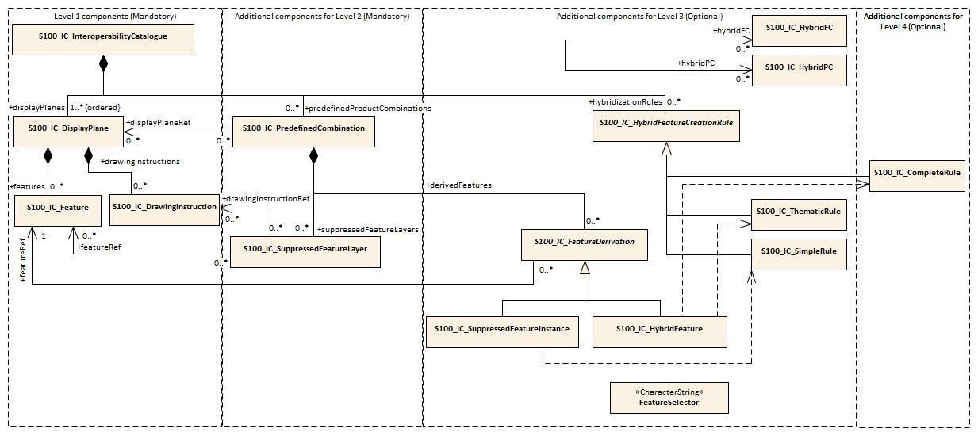

Figure
4
.
1
. Progressive use of
I
nteroperability
C
atalogue model

5

Coordinate Reference Systems (CRS)

The
I
nteroperability
C
atalogue does not have a CRS of its own, and it is therefore expected that the
interoperability
-
ready product’s own CRS should be used by the viewing system to generate the portrayal.
Product
S
pecifications created for the primary use in Inland ECDIS
are

strongly recommended to use EPSG:4326
(
WGS84) for CRS.

6

Data Quality

Data quality allows users and user systems to assess fitness for use of the provided data. Data quality
measures and the associated evaluation are reported as metadata of a data product. This metadata
improves interoperability with other data products and
provides usage by user groups that the data product
was not originally intended for. The secondary users can make assessments of the data product usefulness
in their application based on the reported data quality measures.

For S
-
403
, two aspects of data quality need to be considered: the quality of the data displayed on the
navigation screen
;

and the quality of the
C
atalogue itself.

6.1

Quality of displayed data

Data quality in the individual dataset
s

should be kept available and accessible by user selection, either
portrayed in the chart pane or accessible via
P
ick
R
eport. Amalgamating data quality between products is
outside the scope of this
Specification
and is not addressed in
I
nteroperability
C
atalogues.

See also

c
lause
10.7

for portrayal considerations.

Poor design of certain rules and operations

in
I
nteroperability
C
atalogues

may
adversely
affect the quality
of the
displayed end result
.

Clause

8.11

in
this document

describes general considerations

on maintaining
data quality

for various types of

interoperability rules and operations
.

Level
-
dependent guidelines

are

included in Parts
A
-
D

as appropriate.

6.2

Quality of
I
nteroperability
C
atalogues

The data quality

DQ
(
)

measures recommended in S
-
97
(Part C) which are applicable to S
-
403

I
nteroperability
C
atalogues

(
IC
)

are indicated in
Table
6
-
1

below. Measures not included in this
T
able
,

or included but
marked N/A
,

are not applicable.

Table 6-1 - Quality elements for S-403 Interoperability Catalogues
No | Data quality element and sub element | Definition | DQ measure / description | Evaluation  3  scope for  IC | Evaluation scope for  4  result
M1 | Completeness / Commission | Excess data present in a dataset, as described by the scope. | numberOfExcessItems / This data quality measure indicates the number of items in the dataset, that should not have been present in the dataset. | dataset | dataset
M2 | Completeness / Commission | Excess data present in a dataset, as described by the scope. | numberOfDuplicateFeatureInstanc es / This data quality measure indicates the total number of exact duplications of feature instances within the data. | dataset | dataset
M3 | Completeness / Omission | Data absent from the dataset, as described by the scope. | numberOfMissingItems / This data quality measure is an indicator that shows that a specific item is missing in the data. | dataset / element | dataset / feature
M4 | Logical Consistency  / Conceptual  Consistency | Adherence to the  rules of a conceptual schema. | numberOfInvalidSurfaceOverlaps / This data quality measure is a count of the total number of erroneous overlaps within the data. Which surfaces may overlap and which must not is application dependent. Not all overlapping surfaces are necessarily erroneous. | N/A | Superseding skin of the earth features with surface geometry.
M5 | Logical Consistency  / Format  Consistency | Degree to which data is stored in accordance with the physical structure of the data set, as described by the scope | physicalStructureConflictsNumber / This data quality measure is a count of all items in the dataset that are stored in conflict with the physical structure of the dataset. | dataset | N/A
M6 | Logical Consistency  / Topological  Consistency | Correctness of  the explicitly encoded  topological characteristics of the dataset, as described by the scope. | numberOfMissingConnectionsUnd ershoots / This data quality measure is a count of items in the dataset within the parameter tolerance that are mismatched due to undershoots. | N/A | Depth or safety contours generated from S-102  (+S-104) data.
3
For the IC evaluation scope, a “dataset” is an entire Interoperability Catalogue file, an “element” is an Interoperability Catalogue component corresponding to one of the classes in the model depicted in S-100 Part 16, Figure 16-3.
4
“Result” means the result of applying interoperability operations to covered data. “Resultant feature” means the apparent feature as it appears on the display after application of interoperability. “Resultant dataset” means the collection of resultant features. A “modified feature” is the feature or drawing instruction resulting from the application of an operation or rule which affects spatial or thematic attributes or their values, including combining or suppressing attributes or generating an instance of a feature defined in the HYBRID Feature Catalogue in Level 3 or 4. A “superseding feature” is a feature which suppresses a feature (instance or type) from another dataset, or whose priority is increased above that of a feature which would otherwise overlie it. A “superseded feature” is one that is suppressed or overlaid by a superseding feature.

No | Data quality element and sub element | Definition | DQ measure / description | Evaluation  3  scope for  IC | Evaluation scope for  4  result
M7 | Logical Consistency  / Topological  Consistency | Correctness of  the explicitly encoded  topological characteristics of the dataset, as described by the scope. | numberOfMissingConnectionsOve rshoots / This data quality measure is a count of items in the dataset within the parameter tolerance that are mismatched due to overshoots. | N/A | Depth or safety contours generated from S-102  (+S-104) data.
M8 | Logical Consistency  / Topological  Consistency | Correctness of  the explicitly encoded  topological characteristics of the dataset, as described by the scope. | numberOfInvalidSlivers / This data quality measure is a count of all items in the dataset that are invalid sliver surfaces. A sliver is an unintended area that occurs when adjacent surfaces are not digitized properly. The borders of the adjacent surfaces may unintentionally gap or overlap to cause a topological error. | N/A | Superseding skin of the earth features with surface geometry.
M9 | Logical Consistency  / Topological  Consistency | Correctness of  the explicitly encoded  topological characteristics of the dataset, as described by the scope. | numberOfInvalidSelfIntersects / This data quality measure is a count of all items in the dataset that illegally intersect with themselves. | N/A | Depth or safety contours generated from S-102  (+S-104) data.
M10 | Temporal Quality /  Temporal  Consistency | Consistency with time. | temporalConsistencyStatement / Correctness of ordered events or sequences, if reported. | N/A | Superseding or modified features with time intervals, fixed/periodic date ranges, schedules, or other attributes of (or derived from) type Time,  DateTime, or S100_Truncat edDate.
M11 | Aggregation  Measures /  AggregationMeasur es | In a data product specification, several requirements are set up for a product to conform to the specification. | DataProductSpecificationPassed / This data quality measure is a boolean indicating that all requirements in the referred data product specification are fulfilled. | dataset | N/A
No | Data quality element and sub element | Definition | DQ measure / description | Evaluation  3  scope for  IC | Evaluation scope for  4  result
M12 | Aggregation  Measures /  AggregationMeasur es | In a data product specification, several requirements are set up for a product to conform to the specification. | DataProductSpecificationFailRate / This data quality measure is a number indicating the number of data product specification requirements that are not fulfilled by the current product/dataset in relation to the total number of data product specification requirements. | dataset | N/A

6.2.1 Test methods
Test methods consist of executing the relevant tests from Annex B (Validation Checks) corresponding to the quality elements in Table 6-1 and counting the number of instances in the dataset which fail the checks for that quality element.
Note that in some cases “executing the relevant test” may involve comparing the result to the source material by visual means. For tests requiring visual comparison of encoded data to source material, sampling methods may be used (or test datasets developed for S-403) since the volume of data and number of datasets preclude checking all relevant data objects.

6.2.1.1 Accuracy computations
The recommendations in the respective Product Specifications for covered data products apply to the evaluation of positional accuracy for quality measures. In the absence of a recommendation in the appropriate Specification, the recommendations in S-97 Part C apply.
For spatial primitives resulting from applying spatial operations to feature geometry in input products, the appropriate principles of error propagation should be applied. Since this need arises only for Level 4 Interoperability Catalogues, the relevant principles will be outlined in Part D of S-403.

6.2.2 Data quality testing and reporting
S-403 Catalogues must be tested with the S-403 specific validation checks prior to release. Interoperability Catalogue developers must review the check results and address any issues to ensure sufficient quality of the data products. The checks are listed in Annex B.
Production and certification processes for S-403 Interoperability Catalogues should include a standalone quality report which provides full information on the original results (with evaluation procedures and measures applied).
Quality reports accompanying S-403 Exchange Sets which are distributed to end users need include only the Data Quality Measure Aggregation results to indicate if the Interoperability Catalogue has passed the quality checks defined in this Product Specification. The format must be the standard quality report format defined in S-97 Part C.

7 Performance Standards for ECDIS
Inland ECDIS and ECS that implement this Specification will still be subject to the rules and limitations put in place by all applicable Performance Standards.

8 How to Make Product Specifications Interoperable
This clause provides guidelines for how to identify concepts that need to be factored into an Interoperability Catalogue, and suggestions for how to design rules to implement interoperability. Moreover, these guidelines can be useful in the development of Product Specifications that will be included in an Interoperability Catalogue destined for Inland ECDIS and ECS.
The guidance in this clause can be used in all four levels of Interoperability Catalogues. Level-specific guidance, if any, is provided in the relevant Parts of this Specification.
For portrayal considerations, see Section 10.

8.1 Duplicated features
Perhaps the most significant issue to deal with when considering interoperability is how to deconflict duplicated features between layers. The following paragraphs deal with major categories of duplicate features.
NOTE: Level 1 and Level 2 interoperability modes only permit the creation of rules which apply to all instances of a feature class, or a subset of that feature class as determined by filter expressions. Suppressing or promotion of single feature instances requires interoperability Level 3 or 4 Catalogues.

8.1.1 Duplicated features same model
Where there are equivalent models with same feature concept and attribute bindings, there still may be different attribute values due to issues with maintaining the same update sequence between different products. When considering this for the Interoperability Catalogue, priority should be given to the product that is most likely to be up to date with the latest information.
Developers of Product Specifications that are expected to be used in an Inland ECDIS or ECS in interoperability mode should consider if the features within the Specification are likely to be more frequently updated than those of the IENC or other products that may serve as a base layer or base layer combination for the product being developed. These considerations should be factored in when describing the production of the product and envisioned future use of the product.

8.1.2 Duplicated features, different models
Where the feature concept, attribute bindings, and values of selected attributes are mostly the same but there are minor differences in the different products, such as extra attribute bindings, the Interoperability Catalogue should consider which version of the feature is the higher value for the end user, and give that version priority. There may be different answers depending on the operational situation that the predefined combination tries to support, and this must be considered as part of constructing the Interoperability Catalogue.
EXAMPLE: Interoperability Catalogue developers compare the specifications and data samples of Pilot Boarding Place features from a “Piloting Information” data product and the Pilot Boarding Place features in S-401 and decide that features from the “Piloting Information” datasets have more value in approach and harbour entry scenarios.
Giving a version priority can be implemented in Level 1 (by adjusting display planes and display order) or in Level 2 (by suppressing a feature layer). As mentioned earlier, the answer may depend on the operational situation for which the Interoperability Catalogue is defined.
Developers of Product Specifications should consider how their data model is similar and/or different from other related Product Specifications and the justification for this; and make recommendations to the developers of the Interoperability Catalogue for how to best select between their version of the feature and related features.

8.1.3 Duplicate feature domains
Where feature concepts are different, but the information content is equivalent, considerations should include the update cycle of the information and when creating the Interoperability Catalogue priority should be given to the concept that is most likely to be updated most frequently. Other considerations should include any relations that the concept has to other feature concepts, and consequences of breaking these must be considered when choosing which concept to give the priority and which concept to suppress.
EXAMPLE: Developers investigate the update cycles of real-time current data products and discover that they are updated more frequently than S-401 Current – Non-Gravitational features, and features from the real-time current datasets are therefore preferred replacements for S-401 current features. Note that the question is decided not by comparing dates encoded in features, but on the basis of real-time data that is available on an ongoing basis vs. historical information gathered at a past date.
Product Specification developers should strive to maintain a data model that is as harmonised with related data models as possible. Due considerations should be taken before developing a concept that is different but functionally equal to similar concepts in other Product Specifications.

8.2 Geometry
The geometry of a feature is a significant element that must be considered when developing the Interoperability Catalogue. Similar to other feature attributes, decisions may have to be made to address issues such as selection of one feature over another; for example where types in one product is affected by small scale, while another by large scale, or if merging the two is a better approach.
Issues caused by spatial discrepancies between different products can stem from different causes. The possible solutions to geometry problems depend on the level of interoperability.
If one data product is considered more reliable, or more suitable in a display scale range, the solution may be to give preference to one product or another by either setting the display order (Level 1 – Part A of this Specification) or suppressing a feature layer in one product (Level 2 – Part B of this Specification). Adjustments to geometry are possible only in Interoperability Levels 3 and 4 (Parts C and D of this Specification).
The following paragraphs give more details about options for deconflicting geometry between products with the help of an Interoperability Catalogue and provide pointers to the appropriate Interoperability Level for resolving conflicts. Level-specific guidance, if any, is addressed in the relevant Part of this Specification.

8.2.1 Combined geometry
Where there is a feature in one dataset that effectively augments the geometry of a conceptually different feature in another dataset, Interoperability Catalogue developers need to specify a hybrid feature with portrayal that can correctly portray the combined information. This is possible only in Interoperability Levels 3 and 4. Further guidance on addressing this problem in an Interoperability Catalogue is therefore provided in Parts C and D of this Specification.
EXAMPLE: A dredged area augmented with high definition bathymetry from survey of recent dredging operations giving more water and wider area than dredged area in IENC, combine to give a bigger (new boundary) dredged area than present in IENC.
Developers of Product Specifications that may result in hybrid features when interacting with specific other products, should cooperate with the developers of the related Product Specifications to correctly define the conditions for appropriate use of hybrid features, and communicate these specifications to the Interoperability Catalogue developers.

8.2.2 Spatial discrepancy, unrelated to scaled or cartographic smoothing
If the same feature instances in different data products are expected to have discrepant geometries, Interoperability Catalogue developers should establish the cause of the discrepancy. The cause will probably affect the solution implemented in the Interoperability Catalogue. For example, if one of the data products has more detailed information due to differences in the scopes of the Product Specifications, the Interoperability Catalogue developers should consider suppressing the feature class in the less-detailed product and preferring the same feature class in the product with greater detail. On the other hand, if the discrepancy is found to occur irregularly, it may be more appropriate to suppress the less-detailed instances and prefer the more-detailed instances, independently of the data products to which they belong.
EXAMPLE: IENC has Restricted Area features, while MPA has Marine Protected Area features which show greater details and several sub areas with sub categories.
Resolving this type of discrepancy may require Interoperability Level 2 or higher, since Level 1 only allows changing of display plan and priority, which may cause “ghosting” in displays due to different geometry for nominally co-located features from different data products.
Developers of Product Specifications should examine the Specification scope and consider if it is likely that resulting data products include information that will be better or worse than the same information in other products. For example, if information is only for contextual purposes, it is likely that better information is available in another product and in an interoperability ready Inland ECDIS or ECS these contextual features should be supressed in the presence of more accurate information. Such expectations should be communicated with the Interoperability Catalogue developers who can then add appropriate rules to the Interoperability Catalogue.

8.2.3 Spatial discrepancies, related to scale or cartographic smoothing
Where there is the expectation of differences of geometry for same feature instance in different products it is important to establish the cause, as this will likely impact the solution implemented in the Interoperability Catalogue. If the cause is related to scale or cartographic smoothing in one product over another due to issues such as different scopes (intended use) of the Specifications, the Interoperability Catalogue developers should consider supressing the lesser detailed product and promoting the product with greater detail. If it is irregular occurrences of spatial discrepancies, it may be appropriate to supress the instances where there are less detail and promote the more detailed instances.
EXAMPLE: IENC has approximate surface current instances using climatic data; surface current gridded data has greater details and is daily updated.
Resolving this type of discrepancy may require Interoperability Level 2 or higher, since Level 1 only allows changing of display plan and priority, which may cause “ghosting” in displays due to different spatial types, cartographic smoothing, or different coordinates at different scales for nominally co-located features from different data products.
Developers of Product Specifications should examine the Specification scope and consider if it is likely that resulting data products include information that will be better or worse than the same information in other products. For example, if information is only for contextual purposes or is reduced in detail due to scale, it may be that better information is available in another product and in an interoperability ready Inland ECDIS or ECS these lesser detailed features should be supressed in the presence of more accurate information. Such expectations should be communicated with the Interoperability Catalogue developers who can then add appropriate rules to the Interoperability Catalogue.

8.3 Display of text
For details about display of text, including placement, display selection and management of long text, see Clause 10.8. The Interoperability Catalogue does not address these issues in general terms.
Developers of Product Specifications should be aware that the instructions they place within the Product Specification generally carry through even when the product is used in Inland ECDIS or ECS in interoperability mode. Moreover, text placement issues in interoperability mode are expected to occur at the border between two products which may result in text being partially obscured due to priority issues. OEMs have long experience with solving such issues from S-57 Inland ECDIS and ECS; and advice should be sought with them in how to mitigate such issues. Additionally, clause 10.8 invites OEMs to provide functionality that seek to address most of the issues that cause text to be partially obscured.

8.4 Skin-of-the-earth feature operations
Special care is needed when specifying interoperability for skin-of-the-earth features, to ensure that the result still qualifies as skin-of-the-earth. Consideration should also be given to the effect on alarms and indications.

8.4.1 Skin-of-the-earth feature replacement
As with other operations involving combining geometries, skin-of-the earth feature replacement is possible only in Interoperability Levels 3 and 4. Further guidance on addressing this problem in an Interoperability Catalogue is therefore provided in Parts C and D of this Specification.
NOTE: This clause does not preclude Level 1 or 2 operations on skin-of-the-earth features, if necessary for specific, well-defined, application domains; for example, berthing operations.

8.4.2 Skin-of-the-earth feature adjusting
In interoperability mode, skin-of-the-earth feature adjustment is a specialization of combined geometry, see clause 8.2.1 for details. Also see clauses 10.9 and 10.9.1 for portrayal considerations.
Additional considerations should be given to the attributes of the resulting skin-of-the-earth feature, as a combined feature may have altered geographical representation, attribute combinations or attribute values.
EXAMPLE: Shoaling in a channel in an IENC may be indicated by high definition bathymetry, and a shallower channel hybrid feature replaces the IENC feature, which also has an amended shape. Depth areas adjacent grow due to the shoaling.

8.5 Blended feature concepts
Blended feature concepts or blended portrayals can be produced by using transparency between related features; or creating a temporary blended feature; or blended portrayal (rule and/or symbol) of specific combinations of features from different products. See clause 10.10 for portrayal considerations and example of use case. Blended features or blended portrayal are only possible in Interoperability Levels 3 and 4. Such blended concepts will typically be created by using S100_IC_PredefinedCombination which link to a hybrid Portrayal Catalogue that includes the features to be combined and a suppression rule, for example by using S100_IC_SuppressedFeatureLayer, for the features that are to be replaced.
Developers of Product Specifications that are likely to be used in blended feature concepts by Inland ECDIS and ECS in interoperability mode should communicate their intentions with developers of related Specifications so that awareness is created about the inter-dependencies of these types of relationships. Such communication is especially important when revisions to these Specifications are considered. Doing so will help manage risks to breaking the relationships as the related Product Specifications transition through their life cycle.

8.6 Hierarchy of data
In this context, hierarchy of data means the stacking of data products (layers) within a predefined combination.
In Level 1 interoperability, stacking of data is determined by the interoperability rules which specify the interleaving of display planes, display order and drawing order. Stacking of data products is limited to what can be achieved by interleaving display planes.
In Levels 2, 3, and 4, more control over stacking is possible due to the allowability of feature layer and feature suppression operations, as well as predefined combinations.

8.7 New datasets
New datasets that that are added to an Inland ECDIS or ECS with interoperability mode will be managed by any existing Interoperability Catalogue if the relevant data product is listed in it. Data producers should therefore perform sufficient tests to ensure new datasets perform as envisioned.
See clause 9.7 for additional information about new data products.

8.7.1 New datasets - coverages
New datasets may alter the available coverages of particular data that is used for interoperability views; and therefore any new dataset should be sufficiently tested to ensure performance is as envisioned.

8.7.2 New datasets - maximum and minimum display scales
New datasets may alter the available data in particular scales and/or scale bands, for example, by adding or removing data coverage. Considerations should therefore be given to harmonization of maximum and minimum display scales when a new dataset is provided.

8.7.3 New datasets - feature geometry
New datasets may alter the available feature geometry of available data that is used for interoperability views. Changes include extending or reducing size of areas, changing geometry type from area to point, point to area, area to line or line to area. Therefore, any new dataset should be sufficiently tested to ensure performance is as envisioned.

8.7.4 New datasets - types and attributes
New datasets may change type and attributes of instances in the Inland ECDIS or ECS, for example a platform may be removed and an obstruction remain. These changes may impact the situational view created by the Interoperability Catalogue as changes to feature classes and attribute combinations may mean objects are no longer covered by conditions specific to a predefined combination, or new objects are now covered. Therefore, any new dataset should be sufficiently tested to ensure performance is as envisioned.

8.8 Dataset scales, loading and unloading
Developers of Product Specifications and producers of data should make every effort to harmonize effects of maximum and minimum display scales at loading/unloading time between related products to control over-scale indicators and datasets, in order to avoid situations where one overlay is in scale but not another.

8.9 Metadata
This Edition of the Specification does not provide for comparing information that is not encoded as attributes of feature (or information type) instances. This means that metadata cannot be used in interleaving, filters, or rules unless it is encoded in feature attributes (for example “horizontal position uncertainty” attributes) or meta-features (for example Quality of Bathymetric Data). If Product Specification authors envisage a need to use metadata in interoperability, the Application Schema should be designed so as to make the relevant metadata available as feature attributes or meta-features.

8.9.1 Meta-features
Using information from meta-features in interoperability operations may involve spatial operations and thus require an Interoperability Catalogue to implement Level 3. If spatial operations are not required, metafeatures can be treated like ordinary features (see however clause 10.7 on portrayal of meta-features).
Note that Product Specifications may or may not define portrayal rules for meta-features.

8.9.2 Quality considerations
In choosing to prefer any data product, feature type, or feature instance to another (especially in the context of clauses 8.1, 8.2, and 8.4), developers of Interoperability Catalogues must consider the effects on the quality of the result. The general rule of thumb should be to avoid replacing a higher-quality product (or feature) with a lower-quality product (or feature). Interoperability Catalogue developers should note that this decision should be made after assessing various factors affecting quality, including encoded uncertainty values as well as the age of data, rate of data degradation over time, and potentially also local knowledge.

9 Maintenance
This clause describes the potential sources for change to an Interoperability Catalogue, together with the processes that should be considered when implementing a change to the Interoperability Catalogue.

9.1 Maintenance and update frequency
Changes to this Specification will be released by the IEHG as a New Edition, revision or clarification. Details of what constitute a New Edition, revision or clarification are found in clause 1.5.1. This Specification will be periodically reviewed by the IEHG at intervals of no less than 5 years for confirmation or update. New Editions, revisions and clarifications may be released more frequently as needed.

9.2 Typical sources of change
Due to the nature of Interoperability Catalogues as a set of rules describing how a limited list of products are to interoperate within an Inland ECDIS or ECS, the majority of all data sources for change will be from the listed supported products. Exceptions to this general practice will be when a new Product Specification is added to the list of supported products; along with changes to any relevant Inland ECDIS or ECS related standards from IMO, IEC and IHO that could be a source for change to an Interoperability Catalogue.

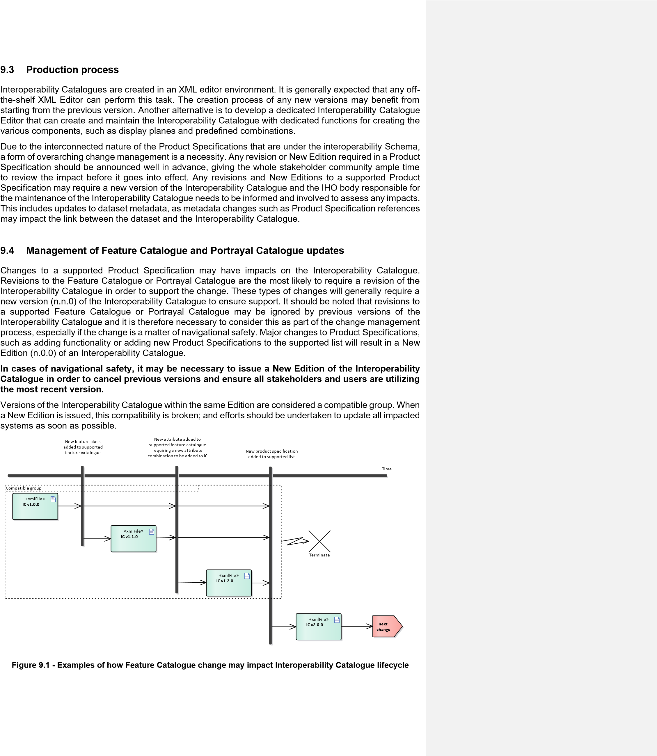
Several types of changes to supported Product Specifications may impact the Interoperability Catalogue in such a way that a new version is needed to maintain full support. These include:
- New feature added to a supported Product Specification that requires a new feature combination to be added to the Interoperability Catalogue;
- New attribute added to a feature in a supported Product Specification that requires a new attribute combination to be added to the Interoperability Catalogue;
- New Product Specification is added to the list of supported Product Specifications in the Interoperability Catalogue. This could also require new feature and attribute combinations to be added;
- Removal of feature or attribute from a supported Product Specification that are present in a feature or attribute combination within the Interoperability Catalogue;
- A correction to a supported Product Specification that triggers a version increment (n.n.0), which may break the link from the Interoperability Catalogue to the supported Product Specification;
- Matters of navigational safety as they arise.
New functions in either a supported Product Specification or the Interoperability Specification may require a new version of the Interoperability Catalogue.

9.5 Product Specification updates other than FC/PC
Updates to dataset metadata, such as Product Specification references, may impact the link between the dataset and the Interoperability Catalogue and therefore require a revision to the Interoperability Catalogue (n.n.0). Some changes to an interoperability-ready Product Specification may not require any changes to the Interoperability Specification or the Interoperability Catalogue. This includes amendments to the definitions of features, attributes or attribute values. It also includes minor changes to Product Specifications, such as clarifying language. Other changes may only require an update to the metadata of the Interoperability Specification and/or the Interoperability Catalogue, such as in case of supported Product Specification version references. Such minor changes to the Interoperability Specification and/or the Interoperability Catalogue may be collected and be applied at a later time when a more substantial revision is required.

9.6 Unpredictable Product Specification updates
Unpredictable changes to an interoperability-ready Product Specification, or its Feature Catalogue and Portrayal Catalogue, should be avoided. Great care should be taken in coordinating changes among all stakeholders to avoid any unforeseen consequences. Product Specifications that are under the Inland ECDIS and ECS interoperability umbrella are interconnected and the responsible groups should therefore coordinate changes with other groups that issue interoperability-ready Product Specifications. Such coordination can be done, for example, by having an agreed fixed period between releases in which all pending changes are collected, implemented and issued in a coordinated fashion.
NOTE: If a situation arises where a product is not compatible with the Interoperability Catalogue, this product will only be available in interoperability mode Level 0. This means it may be displayed as an overlay that may obscure any data below the incompatible product, and the overlay may be obscured by any data with higher priority.

9.7 New data products
When a new product is added to an existing Interoperability Catalogue, a new version of the Interoperability Catalogue will be required. During the development of the new version, the Interoperability Catalogue developers should review existing predefined combinations for impact in addition to developing the new predefined combinations to manage the situational views that the new product is intended for.
An Interoperability Catalogue can be extended to include products not yet defined in the S-100 milieu, provided they comply with the same S-100 Edition as the other products in the Catalogue. As for any other new data product, such scenarios will require a New Edition of the Interoperability Catalogue.

9.8 Backward compatibility
Different versions of data products may be simultaneously active; the Interoperability Catalogue design allows for backward-compatible updates if and when the Interoperability Catalogue has to be updated, within the same major Edition. Figure 9.2 below shows an example of how the Interoperability Catalogue may evolve with change over time.
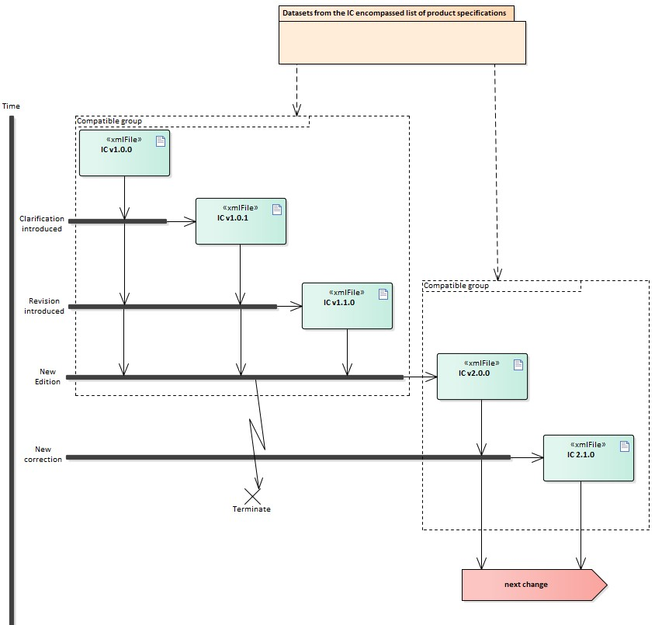
Figure 9.2 - Example life cycle of Interoperability Catalogue

10 Portrayal
This clause provides guidelines and instruction to portrayal considerations related to the use of the
Interoperability Catalogue in an Inland ECDIS or ECS. The Interoperability Catalogue must apply to the specific Product Specifications listed in the Interoperability Catalogue metadata, interoperabilityCatalogueProducts attribute under S100_IC_CatalogueMetadata.
There may be additional data products present in the S-100 Inland ECDIS or ECS that are external to the Interoperability Catalogue; in such cases the Interoperability Catalogue should continue to function in the presence of products not defined in the Catalogue. Data products that are outside of the interoperability scope must be treated in Interoperability Level 0 (see clause 9.6).

10.1 Display of significant features
Significant features in a display plane should have the highest displayPriority value within the S100_IC_DisplayPlane. Care should also be given to assigning significant features with high drawing order values within the relevant S100_IC_Feature and S100_IC_DrawingInstruction. This ensures that less significant features in one data product are not displayed more prominently than more significant features in another product.

10.2 Display of significant features - switching to original
Users must be provided with a means to easily switch on and off the interoperability functionality and display only the IENC data.

10.3 Portrayal distinguishability - colour set-asides
Special consideration must be made when creating portrayal rules related to colour choices for a Product Specification that is on the list of Inland ECDIS and ECS relevant Product Specifications. S-401 IENC portrayal follows the rules laid out in S-4, where it is stated that certain colours have specific meaning. For example, S-4 gives indications for magenta line meaning something non-physical, while black colour implies a physical item. See IHO S-4, clauses B-141 to B-145 for additional details.
On IENC the light sectors marking intricate inshore channels in, for example, Scandinavian waters are shown in red, green, and yellow.
S-403 conforms to the principles for the use of colour set-asides as described in S-100 Part 16.

10.4 Day/night/dusk modes
It is required that every Product Specification that is included in the supported list has colours specified for day, dusk, and night modes. The system must utilize these colours depending on the mode the viewing system is set to.

10.5 Impacts on viewing groups
The viewing group is a concept to control the content of the display. It works as an on/off switch for any drawing instruction assigned to the corresponding viewing group. The concept can be seen as a filter on the list of drawing instructions [S-100 Part 9, Clause 9-11.1.3].
Interoperability Catalogue viewing groups take precedence over the applicable viewing groups for those feature instances in a supported Product Specification, and that are included in a S100_IC_DrawingInstruction or S100_IC_Feature instance.

10.6 Impacts on Portrayal Catalogues
Viewing systems must manage the visibility and display priority of data products, especially relative to radar or AIS display. Moreover, systems must ensure significant features with over radar flag, in all products are distinguishable in the presence of radar and AIS. Tracks and vessel position information are high priority but AIS ASM (application specific messages) may carry lower-priority information, including data described by an S-100 based Product Specification (for example meteorological and hydrographic information as described in S-104).

10.7 Meta-features
In general, the viewing system should allow display of meta features for only one product at a time. This is in order to minimize display clutter, user confusion, and the possibility of interpreting meta-features for one product as applying to a different product.
This means, for example, that data quality meta features for different on-screen products should not be displayed simultaneously, and that only the top most product data quality should be shown at any given time. This also applies in areas of the screen where the topmost product does not cover.

10.7.1 Data quality for individual products
This clause applies to the case where multiple products are on-screen and quality meta-features are enabled. Only one set of quality features should be displayed at any given time to avoid clutter and misreading the meaning of the quality metadata.
Interoperability Catalogues do not specify means of distinguishing data quality portrayals for individual products. Product Specifications must provide rules for display of data quality metadata (including data quality meta-feature information), which the Inland ECDIS or ECS will use to portray data quality.
Means of distinguishing data quality portrayals for individual products is left to the Product Specification authors (in particular, Portrayal Catalogue authors) and OEMs, and can be handled by distinguishing portrayal rules or symbology for different products’ data quality meta-features, such as colour coding or special line symbol. There should also be a clear on-screen message saying what data quality features are displayed in order to give users a firm indication of the layer to which the currently displayed quality metadata applies.

10.7.2 Portrayal of data quality for combinations
Interoperability Catalogues do not include combining data quality portrayals. The recommendation in clause 10.7 about displaying only one set of meta-features is strengthened for data quality in particular. This Specification recommends against simultaneous portrayal of data quality from different products.
Since IENC data is expected to be the base layer in most, if not all, combinations, the IENC data quality may not be shown if only top layer data quality is displayed. This would force users to turn off all other layers in order to see IENC data quality features on the graphic display. It is therefore recommended that OEMs include functions to let the user select which product’s data quality should be displayed.

10.8 Display of text
Text is typically the last item drawn, before own ship. In general, rules for placement, display selection, and management of long text are defined in the individual Product Specification. The Interoperability Catalogue would, in general, only govern when a feature that text is generated from is displayed.
If the centre of the text bounding box falls outside of the dataset area, then it must not be drawn.
NOTE: OEMs may add functions for enhanced automatic text placement.

10.9 Skin-of-the-earth operations and portrayal
Skin-of-the-earth interoperability functionality depends on the Interoperability Level. Common among all the Levels is that anything that replaces S-401 skin-of-the-earth features, will overwrite it by having a higher priority; that is, drawn later. Parts A-D describe the portrayal considerations related to skin-of-the-earth interoperability in Levels 1-4.

10.10 Blended portrayals
When combining various layers that may be of different compilation scale and coverage it is likely that symbols and area patterns will end up at borders, or conflict with symbols and area patterns in other layers. It is important that symbols remain legible, and that OEMs use appropriate methods to avoid displaying partial symbols, or “grafting” part of lower-layer symbols onto symbols in upper layers.
For area fills the symbols of a pattern fill must be closer together for a small or narrow area, to ensure enough symbols are seen, and farther apart for a large area, to avoid clutter. An area pattern may be substituted by a single centred symbol if sufficient space is not available for a pattern to be shown.

10.11 Hierarchy of data
Hierarchy between different Product Specifications can be influenced by several factors such as intended use and navigational operation. It may not be possible to prescribe a fixed hierarchy list as a universal standard, and the Interoperability Catalogue model therefore offers a flexible approach. Within the Interoperability Catalogue the hierarchy of data between different S-100 based Product Specifications is determined using predefined combinations (which are allowed only in Level 2 and higher). The DisplayPlanes referenced within a PreDefinedCombination give the order of feature layers.

10.11.1 Interacting gridded information
If two or more gridded data types are to interact, the hierarchy between them should be established using predefined combinations as with other data types. Particular care has to be taken depending on how the presentation of the data is to be done when deciding which gridded data type has the highest priority, considering items such as will one gridded data type obscure the other.
For example, gridded bathymetry will likely obscure gridded surface currents and therefore the gridded surface currents should be given the highest priority between the two if they are to be displayed simultaneously.

10.12 Pick Reports
Pick Reports may be defined in the individual Product Specifications. The Interoperability Catalogue permits reuse of these specifications as it does not specify Pick Report design for the individual supported Product Specification. This Specification rather outlines the general principles that apply to Pick Reports when a system is used in interoperability mode. Future Editions of S-403 should define either behaviour that works the same for every product, or some form of machine readable filters or styling rules to present content which can be customized by products and remain consistent with the Pick Report guidelines in S-52 or its applicable successor Standard for S-100-based products.

10.12.1 Combined Pick Reports
In interoperability mode, Pick Reports should be combined into one Pick Report that contains information from all visible underlying products. Data should be organized to facilitate navigation through complex reports. Structures such as expandable tree controls, tabs or other GUI implementations could be used to help the user navigate the structure of the Report based on the layers and features included. For example, a tree structure could be presented to the user, where the top most layer is the open branch, and the lower layers are closed branches, by default, but can be expanded by the user as required. Each branch should support the particulars of the Product Specification that is represented by that branch.
Means must be provided to distinguish which product a feature comes from, for example the product can be used as a “namespace prefix” for attributes or objects.
S-401: RestrictedAreaNavigational:…
S-122: RestrictedAreaNavigational:…
Pick Reports may create a display that combines attributes from features from different products, and it should then be possible to distinguish where the attribute is from. For example, the method below may be used.
RestrictedAreaNavigational
S-401: restriction:…
S-122: restriction:…
NOTE 1: OEMs may include a common Pick Report style for all the visible data layers, but must provide means for easy access to Product Specification defined reporting styles.
NOTE 2: The scope of this recommendation and the definition of defaults and reporting styles are under development in S-403 Edition 0.0.1.

10.12.2 Prioritized Pick Reports
Pick Report content should by default be prioritized in a manner consistent with how the layers are presented, with the highest priority content presented in precedence to lower priority content (“precedence” meaning before, etc, depending on the user interface structure and user expectations). OEMs may provide additional sorting methods as long as the user can easily link the information in the Pick Report to the respective layers.

10.12.3 Full information availability
Complete data from all products visible on the screen must be available to the Inland ECDIS or ECS user, irrespective of all these products being in the scope of the Interoperability Catalogue or not.
Features that have been visually suppressed must not be included in the Pick Report.

10.13 User control over loaded set
Users must always have the option to load an additional product, or turn off one or more of the data products in a predefined combination. Portrayal must adjust to the loaded set as appropriate, for example if an additional product is loaded, it should be interleaved with layers from data products in the predefined combination according to the drawing priorities and drawing order in its Portrayal Catalogue.
The user interaction aspect of user control over loaded data products are discussed in clause 15.3.

10.14 User control over Interoperation Level
Users must always have the option to select the Interoperability Levels they wish to use. Only predefined combinations that correspond to the Levels chosen should then be available to the user. Alternatively, the user should be warned if picking a predefined combination that is not among the Interoperability Levels already selected.
The user interface aspects of user control over interoperation level are addressed in clause 15.4.

11 Data Product Format (Encoding)
The format for S-403 interoperability catalogues conforms to the rules in S-100 Part 16.
Format Name: | XML
Version: | 0.0.1-YYYYMMDD
Character Set: | UTF-8
Specification: | S-100 5.0.x Part 16
The data format version is of the form <edition>.<revision>-<build> (or <edition>.<revision>.<clarification><build>). The <edition>.<revision> sequence will be the same as the corresponding components of the Interoperability Specification version. (The <clarification> component is optional, but if present will be the same as the clarification component.) The YYYYMMDD component is a build date for the XSD files which constitute the machine-readable data format description. This format allows harmonization of the version numbering of the XSD files and this Specification. (Clarifications to the specification will generally not require changes to the XSD files, but if they do, a new set with <clarification> and new <build> date will be issued.)
The dictionary for the list of data products covered by S-403 is provided in a file named “403CCCCDICTIONARY.XML” (where CCCC is the producer code – see clause 12.3.1) whose contents conform to the ISO 19115-3 format for “codelist” files. This file accompanies the S-403 XSD distribution.
EXAMPLE: For an Interoperability Catalogue issued by IHO, the dictionary file is named using the IHO producer code “00AA” in place of “CCCC”. The dictionary file is therefore named: 40300AADICTIONARY.XML
The dictionary file must be included in every S-403 base Exchange Set as a support file, and documented in Exchange Set metadata as a support file. The recommended location for this file in an S-403 Exchange Set prepared by IEHG is in a “resources” folder within the Exchange Set. Distributors are permitted to use alternate locations since the location of support files within Exchange Sets is discoverable from the discovery metadata for support files.
XML Schemas and samples of Interoperability Catalogues for different Levels are available from the IHO schema/sample server (<https://schemas.s100dev.net>). The S-403 specific constraints on the S-100 generic Schemas for Interoperability Catalogues are checked by means of Schematron rules, also available at the aforementioned IHO Schema distribution site. The IEHG dictionary file for S-403 products (clauses 4.1.1, 11, 12.3) is also available at the same site.

12 Data Product Delivery

12.1 Introduction
This clause specifies the encoding and delivery mechanisms for an Interoperability Catalogue. Data which conforms to this Specification must be delivered by means of an Exchange Set as specified in S-100 Part 17.
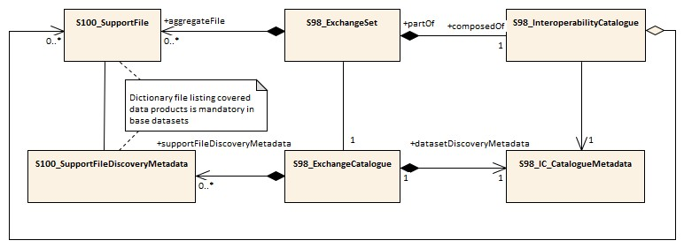

Figure 12.1 - Exchange Set structure for base catalogue set
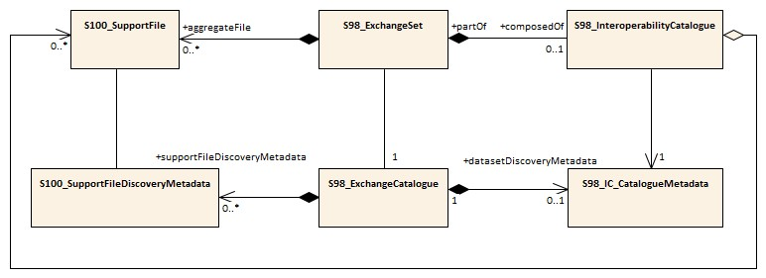
Figure 12.2 - Exchange Set structure for update catalogue set

Units of Delivery: Exchange set
Transfer Size: Unlimited Medium Name: Digital data delivery
Other Delivery Information:
The Interoperability Catalogue Exchange Set has a single Exchange Catalogue which contains the discovery metadata for the Interoperability Catalogue and any associated support files.
S-403 edition 0.1 provides for interoperability catalogues to be updated by means of a new edition of the interoperability catalogue. An exchange set containing an interoperability catalogue must have at least one Interoperability Catalogue, and may have a hybrid Feature Catalogue and/or a hybrid Portrayal Catalogue.
A interoperability catalogue must be accompanied by a support file in dictionary format listing the covered products. Clause 11 describes this file.
An Exchange Set may be encapsulated into a form suitable for transmission by a mapping called a transmission encoding. An encoding translates each of the elements of the Exchange Set into a logical form suitable for writing to media and for transmission online. An encoding may also define other elements in addition to the Exchange Set contents (that is, media identification, data extents etc…) and also may define commercial constructs such as encryption and compression methods.
If the data is transformed (for example for encryption or compression purposes) its content must not be changed.

12.1.1 Interoperability Catalogue in different formats
The Interoperability Catalogue may be substituted by equivalent catalogues or presentations developed by manufacturers or service providers, provided the minimum functions are maintained and the producer of the replacement Interoperability Catalogue can prove this through testing.

12.1.2 Extending the Interoperability Catalogue
The Interoperability Catalogue will be extensible with equivalent rules or presentations developed by manufacturers or service providers, provided the minimum functions are maintained and the producer of the augmented Interoperability Catalogue can prove this through testing.

12.1.3 Customization - OEM/integrator
OEM or service providers can provide their own versions in addition to the IEHG Catalogue, to facilitate custom product interoperations. These additional versions must not degrade or interfere with the functions of the official IEHG Interoperability Catalogue.

12.2 Interoperability Catalogue product
Each Interoperability Catalogue product is by itself a whole unit. New versions – either clarification, correction, or New Edition – are updated by replacement with a newer version.

12.2.1 Interoperability Catalogue size
There is no size limit for Interoperability Catalogue products, however, compression is used to reduce the Exchange Set size.

12.2.2 Interoperability Catalogue Exchange Set compression
An Interoperability Catalogue Exchange Set must be compressed into a single archive using the ZIP algorithm with the DEFLATE compression method as specified in S-100 Part 15.

12.2.3 Interoperability Catalogue file naming
Interoperability Catalogues must follow the naming convention below, where the main part forms an identifier where:
403CCCCXXXXXX.XML
- The first three characters must be 403 – for S-403 Interoperability Catalogues.
- The next four characters must be the producer code according to the S-100 Producer Code Register – for example, 00AA for the International Hydrographic Organization as the issuing organization.
- The eighth to thirteenth characters are for the version number to ensure the file name is globally unique. Version 1 would be 010000 [01.00.00].
The extension must always be .XML.

12.3 Support files
Interoperability Catalogues at all levels require a “dictionary” file containing a list of the “standard” data products covered by the Catalogue.
Interoperability Levels 3 and 4 may require support files in the form of hybrid Feature Catalogues and hybrid Portrayal Catalogues. Methods for managing these in Parts C and D.

12.3.1 Support file naming
403CCCCFFXXXXXXXX.XML
Support file names must follow the naming convention below:
- The first three characters must be 403 – for S-403 Interoperability Catalogue support files.
- The next four characters must be the producer code according to the S-100 Producer Code Register – for example, 00AA for the International Hydrographic Organization as the issuing organization.
- The eighth and ninth characters must be FC for Feature Catalogue or PC for Portrayal Catalogue. Other support files must not use “FC” or “PC” for these characters but may use any other twocharacter combination.
- The segment from the tenth to seventeenth characters is for a globally unique alpha numeric code. The following characters are allowed in the support file name, A to Z, 0 to 9 and the special character _ (underscore). Fewer than eight characters may be used in this segment.
The extension must always be .XML.

12.3.2 Support file management
When a support file is created or a subsequent version is issued it must carry its own issue date and be supported with a digital signature which authenticates it against the IHOs public key included in the Exchange Set metadata.
The type of support file is indicated in the “purpose” field of the discovery metadata. Support files carrying the “deletion” flag may be removed from the Inland ECDIS or ECS.
Support files should be stored in a separate folder within the Exchange Set.

12.4 Exchange Catalogue
The Exchange Catalogue acts as the table of contents for the Exchange Set. The catalogue file of the Exchange Set must be named CATALOG.XML. No other file in the Exchange Set may be named CATALOG.XML. The contents of the Exchange Catalogue are described in clause 13 (Metadata).
The Exchange Catalogue format is described by an XSD file that extends the S-100 Exchange Catalogue Schema. The Exchange Catalogue XSD file is available at the IHO Schema distribution location (currently https://github.com/IHO-S100WG).

12.5 Encryption and authentication

12.5.1 Encryption method
Data encryption is not mandatory, however if it is required then it must comply with the mechanisms provided in S-100 Part 15. Part 15 also allows dataset files to be compressed using the zip algorithm (see clause 12.2.2) prior to encryption. Details are provided in S-100 Part 15.

12.5.2 Digital signature
S-403 Interoperability Catalogues must be signed. The signature method, format, and location in the Exchange Set must conform to the method, format, and location described in S-100 Parts 15 and 4a.
IHO being the Scheme Administrator for authentication of S-100 products, an Interoperability Catalogue issued by IHO is therefore self-signed.

12.5.3 Authentication and integrity checks
To ensure that the Interoperability Catalogue has been issued by the purported producer and has not changed during transmission/delivery, authentication and integrity checks are performed as described in S-100 Part 15.

12.6 Updating the Interoperability Catalogue
Several versions of the Interoperability Catalogues may be active at a given time due to backward compatibility within each major Edition. This compatibility is likely to be broken when a New Edition is released. See clause 0 for more details on Interoperability Catalogue maintenance.

12.6.1 Updating the Interoperability Catalogue
Interoperability Catalogues may remain active after a new version has been issued. Systems receiving new versions within the same major edition should retain all versions. Store these in separate folders to avoid any issues, such as when the same support files have been reused between versions.
Due to issues with broken backwards compatibility, all previous versions of the Interoperability Catalogue should be cancelled when a New Edition is issued.

12.6.2 Cancelling a version of the Interoperability Catalogue
In order to cancel a version of the Interoperability Catalogue, a cancellation Catalogue file is created for which the Edition number must be set to 0. Interoperability Catalogue Edition number is a field in Exchange Set metadata, class S100_IC_CatalogueMetadata (see clause 13 on Metadata classes). The cancellation Catalogue file may contain no data objects and any data objects present in it are ignored. The cancellation Catalogue file may be part of an Exchange Set which contains a new version of the Interoperability Catalogue. This method is only used to cancel an Interoperability Catalogue. When a version of the Interoperability Catalogue is cancelled it must be removed from the system.
A cancellation applies only to Interoperability Catalogues meeting the following conditions:
- The issue date and time of the Interoperability Catalogue being cancelled precede the issue date and time of the cancellation itself. Issue date and time are fields in S100_IC_CatalogueMetadata (see clause 13.3.2).
- The version date of the Interoperability Catalogue being cancelled precedes or coincides with the version date of the cancellation Interoperability Catalogue. Version date is a field in the Interoperability Catalogue header (see S-100 Part 16, clause 16-4.4.2.1).
NOTE 1: The issue date in metadata may or may not be the same as the version date in the Catalogue header.
NOTE 2: Verification and management of authority relationships is out of the scope of this Specification, and may have to be an external process (for example verification of signatures and verification that issuer and canceller are the same or successor organizations, or belong to the same or successor organizations).

12.6.3 Updating the Interoperability Catalogue support files
Support files are updated using the method detailed in clause 12.3.2.

12.6.3.1 New Edition of the support files
New Editions of the support files introduce significant changes. New Editions enable new concepts, such as the ability to support new functions, or the introduction of new constructs. New Editions are likely to have a significant impact on either existing users or future users of the Interoperability Catalogue Specification.
EXAMPLE: A new product is added to Interoperability Catalogue, and all support files should be updated to support the new product. This would require a New Edition of the support files.

12.6.3.2 Revisions to the support files
Revisions are defined as substantive semantic changes to the support files. Typically, revisions will change the support file to correct factual errors; introduce necessary changes that have become evident as a result of practical experience or changing circumstances. A revision must not be classified as a clarification. Revisions could have an impact on either existing users or future users of the Interoperability Catalogue Specification. All cumulative clarifications must be included with the release of approved revisions.
Changes in a revision are minor and ensure backward compatibility with the previous versions within the same Edition. Newer revisions, for example, introduce new feature or attribute combinations. Within the same Edition, a support file created for an Interoperability Catalogue of one version could always be processed with a later revision of the Interoperability Catalogue.
EXAMPLE: Adding a new hybrid feature will require a revision increment to the support file.

12.6.3.3 Clarification to the support files
Clarifications are non-substantive changes to the support file. Typically, clarifications: Remove ambiguity; correct grammatical and spelling errors; amend or update cross references; insert improved graphics in spelling, punctuation and grammar. A clarification must not cause any substantive semantic change to the Interoperability Catalogue Specification.
Changes in a clarification are minor and ensure backward compatibility with the previous versions within the same Edition. Within the same Edition, a support file created for an Interoperability Catalogue of one version could always be processed with a later clarification (or revision) of the Interoperability Catalogue.
EXAMPLE: Correcting a spelling error in a definition will require a clarification increment to the support file. 12.6.3.4 Version Numbers
The associated version control numbering in the support file headers must follow the same structure as the Specification itself, see clause 1.8.5. Support files need not follow the version number of the Interoperability Catalogue they belong to, as support files may be updated numerous times between versions of the Interoperability Catalogue.
Version numbers of support files may have a suffix that indicates a “build number” or date of creation or issue of the support file.

13 Metadata

13.1 Introduction
Discovery metadata for Interoperability Catalogues must be provided in XML format conforming to S-100 dataset discovery as specified in S-100 Part 17, with the extensions described in this clause.

13.2 Language
Interoperability Catalogue metadata must be provided in the English language.

13.3 Interoperability Catalogue Metadata elements
Each exchange set has a single CATALOG.XML file which contains meta information for the data and support files in the exchange set.
The exchange catalogue model is shown in Figure 13.1 and its contents are documented in the following sub-clauses.
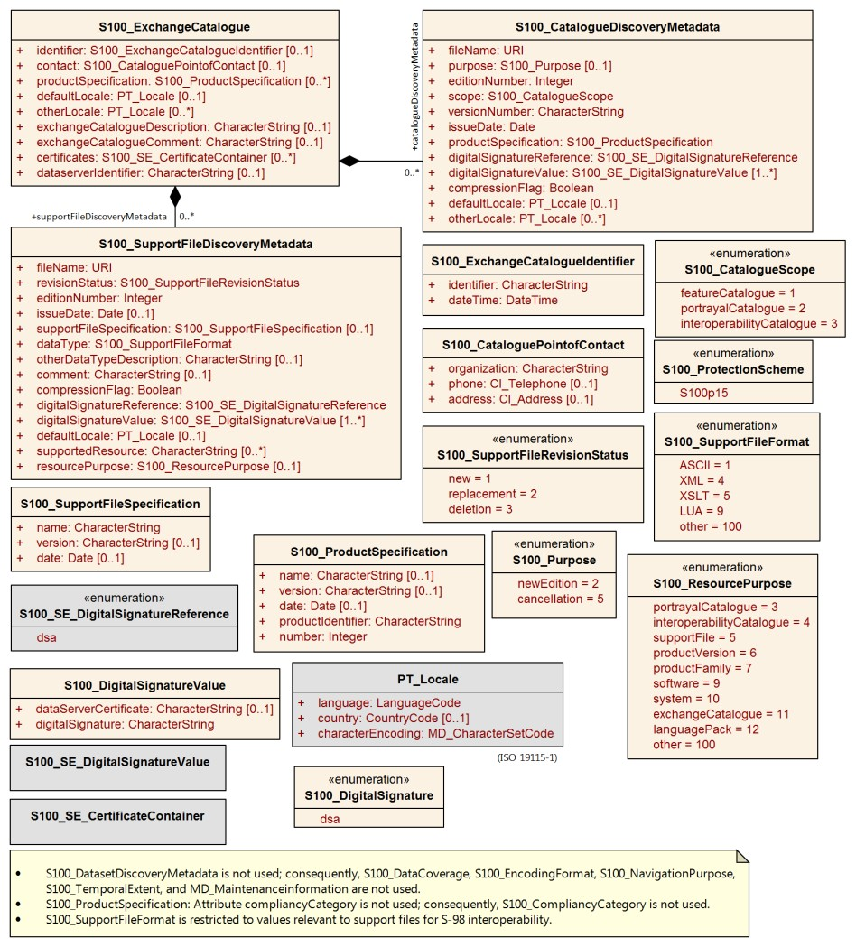

Figure
13
.
1

-

S
-
403
Metadata classes, attributes, and relationships

Page intentionally left blank

13.3.1 S100_ExchangeCatalogue
Role Name | Name | Description | Mult | Type | Remarks
Class | S100_ExchangeCatalogue | An exchange catalogue contains the discovery metadata about the exchange datasets and support files | - | - | The optional S-100 attributes identifier, contact, and productSpecification are mandatory in S-403.
Attribute | identifier | Uniquely identifies this exchange catalogue | 1 | S100_ExchangeCatalogueIdentifier | Mandatory in S-403.
Attribute | contact | Details about the issuer of this exchange catalogue | 1 | S100_CataloguePointOfContact | Mandatory in S-403.
Attribute | productSpecification | Details about the product specifications used for the datasets contained in the exchange catalogue | 1 | S100_ProductSpecification | Mandatory in S-403.
Attribute | defaultLocale | Default language and character set used for all metadata records in this Exchange Catalogue | 0..1 | PT_Locale | Default is English and UTF-8
Attribute | otherLocale | Other languages and character sets used for the localized metadata records in this Exchange Catalogue | 0..* | PT_Locale | Required if any localized entries are present in the  Exchange Catalogue
Attribute | exchangeCatalogueDescription | Description of what the exchange catalogue contains | 0..1 | CharacterString
Attribute | exchangeCatalogueComment | Any additional Information | 0..1 | CharacterString
Attribute | certificates | Signed public key certificates referred to by digital signatures in the Exchange Set | 0..* | S100_SE_CertificateContainer | Content defined in S-100 Part 15. All certificates used, except the SA root certificate (installed separately by the implementing system) shall be included
Attribute | dataServerIdentifier | Identifies the data server for the permit | 0..1 | CharacterString
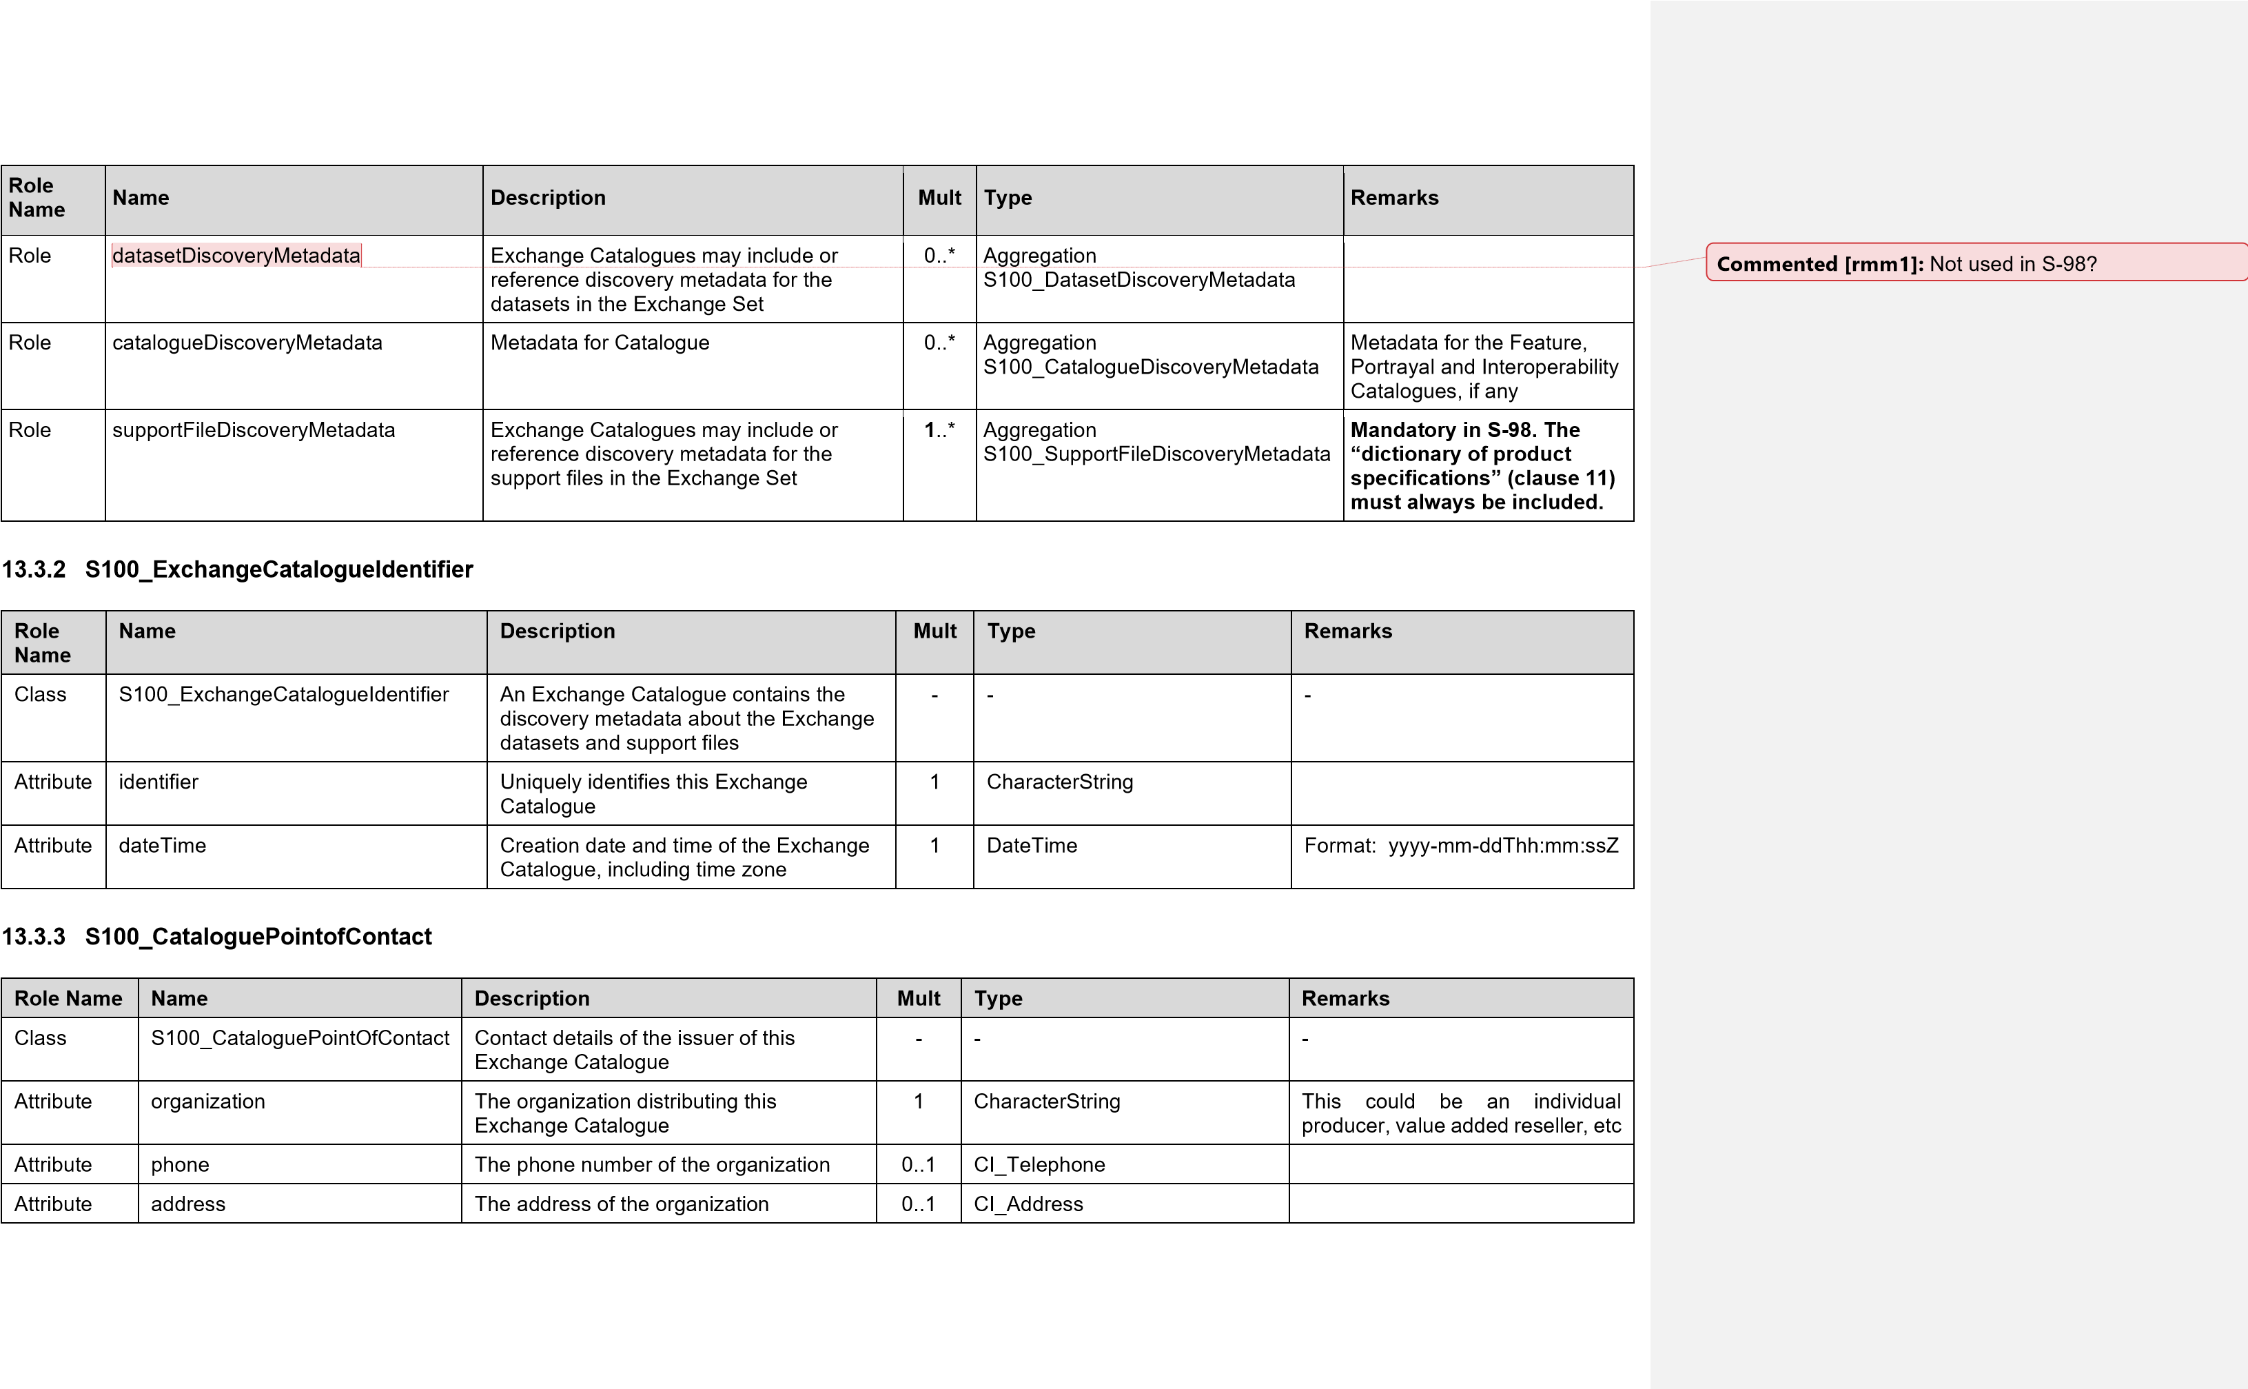

13.3.4 S100_Purpose
Item | Name | Description | Code | Remarks
Enumeration | S100_Purpose | The purpose of the dataset | - | The values newDataset, reissue, update, and delta are not used.
Value | newEdition | New edition of the dataset or Catalogue | 2 | Includes new information which has not been previously distributed by updates.
Value | cancellation | Dataset or Catalogue that has been cancelled | 5 | Indicates the dataset or Catalogue should no longer be used and can be deleted

13.3.5 S100_ProductSpecification
Role Name | Name | Description | Mult | Type | Remarks
Class | S100_ProductSpecification | The Product Specification contains the information needed to build the specified product | - | - | The S-100 attribute compliancycategory is not used.
Attribute | name | The name of the Product Specification used to create the datasets | 0..1 | CharacterString | The name in the GI Registry should be used for this field.  For S-403 Ed. 0.0.1 this is “Data  Product Interoperability in S100 Navigation Systems” (without quotes).
Attribute | version | The version number of the Product Specification | 1 | CharacterString | Mandatory in S-403. Use the version number from the GI Registry., e.g., “1.1.0” (without quotes).
Attribute | date | The version date of the Product Specification | 0..1 | Date
Attribute | productIdentifier | Machine readable unique identifier of a product type | 1 | CharacterString  (Restricted to Product ID values from the IHO Product  Specification Register, in the  IHO Geospatial Information (GI)  Registry) | “S-403” (without quotes)
Attribute | number | The number used to lookup the product in the Product Specification Register of the  IHO GI Registry | 1 | Integer | For Product Specifications these should be taken from the Product Specification  Register in the IHO Geospatial  Information (GI) Registry

13.3.6 S100_ProtectionScheme
Role Name | Name | Description | Code | Remarks
Enumeration | S100_ProtectionScheme | Data protection schemes | - | -
Value | S100p15 | IHO S-100 Part 15 | - | See S-100 Part 15

13.3.7 S100_SupportFileDiscoveryMetadata
Role Name | Name | Description | Mult | Type | Remarks
Class | S100_SupportFileDiscoveryMetadata | Metadata about the  individual support files in the Exchange Catalogue | - | - | -
Attribute | fileName | Name of the support file | 1 | URI | See Part1, clause 1-4.6
Attribute | revisionStatus | The purpose for which the dataset has been  issued | 1 | S100_SupportFileRevisionStatus | For example new, replacement, etc.
Attribute | editionNumber | The Edition number of the dataset | 1 | CharacterString | When a data set is initially created, the  Edition number 1 is assigned to it. The  Edition number is increased by 1 at each New Edition
Attribute | issueDate | Date on which the data was made available by the data producer | 1 | Date | Mandatory in S-403
Attribute | supportFileSpecification | The specification used to create this file | 1 | S100_SupportFileSpecification
Attribute | dataType | The format of the support file | 1 | S100_SupportFileFormat
Attribute | otherDataTypeDescription | Support file format other than those listed | 0..1 | CharacterString
Attribute | comment | Optional comment | 0..1 | CharacterString
Attribute | compressionFlag | Indicates if the resource is compressed | 1 | Boolean | True indicates a compressed resource  False indicates an uncompressed resource
Attribute | digitalSignatureReference | Digital signature of the file | 1 | S100_DigitalSignatureReference (see Part 15) | Reference to the appropriate digital signature algorithm
Attribute | digitalSignatureValue | Value derived from the digital signature | 1..* | S100_DigitalSignatureValue (see Part 15) | The value resulting from application of digitalSignatureReference.  Implemented as the digital signature format specified in S-100 Part 15
Attribute | defaultLocale | Default language and character set used in the exchange catalogue | 0..1 | PT_Locale | A support file is expected to use only one locale, because other files can be created for other languages
Attribute | supportedResource | Identifier of the resource  supported by this support file | 0..* | CharacterString | Conventions for identifiers are still to be developed in S-100.  In the interim, S-403 will use the name of the interoperability catalogue file.
Attribute | resourcePurpose | The purpose of the supporting resource | 0..1 | S100_ResourcePurpose | Identifies how the supporting resource is used

13.3.8 S100_SupportFileFormat
Role Name | Name | Description | Code | Remarks
Enumeration | S100_SupportFileFormat | The format used in the support file | - | S-100 support file formats other than those listed here are not allowed
Value | XML |  | - | Feature Catalogue and Portrayal Catalogue are in XML
Value | XSLT |  | - | For example filters, rules
Value | LUA | A Lua script file | -
Value | other |  | - | For example symbols, etc

13.3.9 S100_SupportFileRevisionStatus
Role Name | Name | Description | Code | Remarks
Enumeration | S100_SupportFileRevisionStatus | The reason for inclusion of the support file in this  Exchange Set | - | -
Value | new | A file which is new | 1 | Signifies a new file
Value | replacement | A file which replaces an existing file | 2 | Signifies a replacement for a file of the same name
Value | deletion | Deletes an existing file | 3 | Signifies deletion of a file of that name

13.3.10 S100_SupportFileSpecification
Role Name | Name | Description | Mult | Type | Remarks
Class | S100_SupportFileSpecification | The Standard or Specification to which a support file conforms | - | - | -
Attribute | name | The name of the Specification used to create the support file | 1 | CharacterString
Attribute | version | The version number of the Specification | 0..1 | CharacterString
Attribute | date | The version date of the Specification | 0..1 | Date

13.3.11 S100_ResourcePurpose
Role Name | Name | Description | Code | Remarks
Enumeration | S100_ResourcePurpose | Defines the purpose of the supporting resource | - | Only the values listed below are allowed for S-403.
Value | featureCatalogue | A Feature Catalogue for an S-100 data product | 2 | Use for hybrid feature catalogues, if included in the exchange set.
Value | portrayalCatalogue | A Portrayal Catalogue for an S-100 data product | 3 | Use for hybrid portrayal catalogues or portrayal catalogues with substitute symbolizations.
Value | productVersion | All datasets conforming to a specific version of an S-100 Product Specification | 6 | For example, a dictionary codelist used in a Product Specification. (Use for S-403 product dictionary files described in clause 11.)
Value | exchangeCatalogue | An Exchange Catalogue | 10 | For example, the “resources file” containing codelists for languages and character set codes, available in the S-100 generic schemas distribution.
Value | other | A type of resource not otherwise described | 100

13.3.12 S100_CatalogueDiscoveryMetadata
Role Name | Name | Description | Mult | Type | Remarks
Class | S100_CatalogueDiscoveryMetadata | Class for S-100 Catalogue metadata. | - | - | -
Attribute | filename | The name for the Catalogue | 1 | URI | See S-100 Part1, clause 1-4.6
Attribute | purpose | The purpose for which the Catalogue has been issued | 1 | S100_Purpose | The values must be one of the following:  2 new edition  5 cancellation  Mandatory in S-403
Attribute | editionNumber | The Edition number of the Catalogue | 1 | Integer | Initially set to 1 for a given productSpecification.number Increased by 1 for each subsequent newEdition  Uniquely identifies the version of the  Catalogue
Attribute | scope | Subject domain of the Catalogue | 1 | S100_CatalogueScope
Attribute | versionNumber | The version number of the Product Specification | 1 | CharacterString
Attribute | issueDate | The version date of the Product Specification | 1 | Date
Attribute | productSpecification | The Product Specification used to create this file | 1 | S100_ProductSpecification
Attribute | digitalSignatureReference | Specifies the algorithm used to compute digitalSignatureValue | 1 | S100_DigitalSignatureReference (see Part 15) | Reference to the appropriate digital signature algorithm
Role Name | Name | Description | Mult | Type | Remarks
Attribute | digitalSignatureValue | Value derived from the digital signature | 1..* | S100_DigitalSignatureValue (see Part 15) | The value resulting from application of digitalSignatureReference.  Implemented as the digital signature format specified in S-100 Part 15
Attribute | compressionFlag | Indicates if the resource is compressed | 1 | Boolean | true indicates a compressed resource false indicates an uncompressed resource
Attribute | defaultLocale | Default language and character set used in the Catalogue | 0..1 | PT_Locale | In absence of defaultLocale the language is English in UTF-8
Attribute | otherLocale | Other languages and character sets used in the Catalogue | 0..* | PT_Locale

13.3.13 S100_CatalogueScope
Role Name | Name | Description | Code | Remarks
Enumeration | S100_CatalogueScope | The scope of the Catalogue | - | -
Value | featureCatalogue | S-100 Feature Catalogue | - | Only Interoperability Catalogues implementing Level 3 or 4 may be accompanied by a Feature Catalogue
Value | portrayalCatalogue | S-100 Portrayal Catalogue | -
Value | interoperabilityCatalogue | S-100 interoperability information | - | Use this for Interoperability Catalogues

13.3.14 PT_Locale
Role Name | Name | Description | Mult | Type | Remarks
Class | PT_Locale | Description of a locale | - | - | From ISO 19115-1
Attribute | language | Designation of the locale language | 1 | LanguageCode | ISO 639-2 3-letter language codes
Attribute | country | Designation of the specific country of the locale language | 0..1 | CountryCode | ISO 3166-2 2-letter country codes
Attribute | characterEncoding | Designation of the character set to be used to encode the textual value of the locale | 1 | MD_CharacterSetCode | UTF-8 is used in S-100

13.3.15 Types for digital signatures
The types relating to digital signatures:
- S100_SE_CertificateContainer
- S100_SE_DigitalSignatureReference
- S100_SE_DigitalSignatureValue
- S100_SE_SignatureOnData
- S100_SE_SignatureOnSignature
- DataStatus are defined in S-100 Part 15 and are used in S-403 without modification.

Page intentionally left blank

14 Processing Model

14.1 Overview of processing
Interoperability processing can either precede or follow portrayal processing (except rendering, which converts feature data into graphics and is necessarily the step just before actual display). A mixed processing model, where interoperability processing is done both before and after portrayal processing, is also possible.
- Option 1 - Interoperability before regular portrayal processing: Feature data from S-401 and other S-100-based datasets is an input to the interoperability processor, along with the Interoperability Catalogue and context parameters. The interoperability processor filters and interleaves feature data according to the Interoperability Catalogue and Interoperability Level selected by the user and passes the resultant feature data to the portrayal processor, which uses the Portrayal Catalogue for individual products to generate drawing instructions for the display processor.
- Option 2- Interoperability after regular portrayal processing: Feature data from S-401 and other S100-based datasets flows to the portrayal processor. The portrayal processor transforms them into drawing instructions. The drawing instructions flow to the interoperability processor. The interoperability processor filters and interleaves the drawing instructions according to the Interoperability Catalogue and Interoperability Level selected by the user and passes the resultant drawing instructions to the display processor.
Both processing options are shown in Figure 14.1 below. This figure extends S-100 Figures 9-2 (Part 9) and 9a-1 (Part 9a) with interoperability concepts. Details of the processing model depend on the Interoperability Level and are provided in Parts A-D.
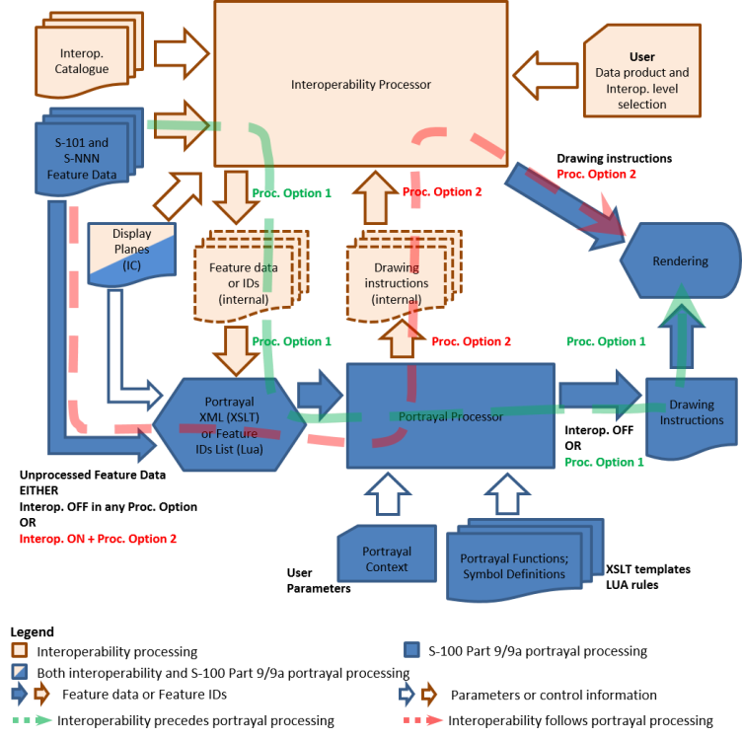

Figure 14.1 – Overview of interoperability processing
In all levels of processing except Level 0 (interoperability off), and Level 1 (which does not include predefined combinations) data products to be loaded are selected by the system according to the list in the predefined combination selected by the boatmaster selection from among those listed in the Catalogue. (In Level 1 they are selected by the boatmaster.) The boatmaster may also select additional data products from the optional load set.
Feature data from products not listed in the Interoperability Catalogue are passed through to portrayal processing as described in S-100 Part 9/9a (stage Portrayal Processing) without any intermediate stages in interoperability processing, and displayed by ordinary S-100 portrayal processing according to their individual Portrayal Catalogues.
Details of the processing model for each level are discussed in the relevant Part of this Specification.

15 User Interaction Constraints and Expectations

15.1 Interoperation requirements for Product Specifications
Responsible parties for Product Specifications that are included in the Interoperability Catalogue should consider the impact on the Interoperability Catalogue and associated Product Specifications throughout the lifecycle of the Product Specification. The general principles of Software Quality Assurance (SQA) as found in section 4 of the Annex to MSC.1/Circ.1512 should be applied.
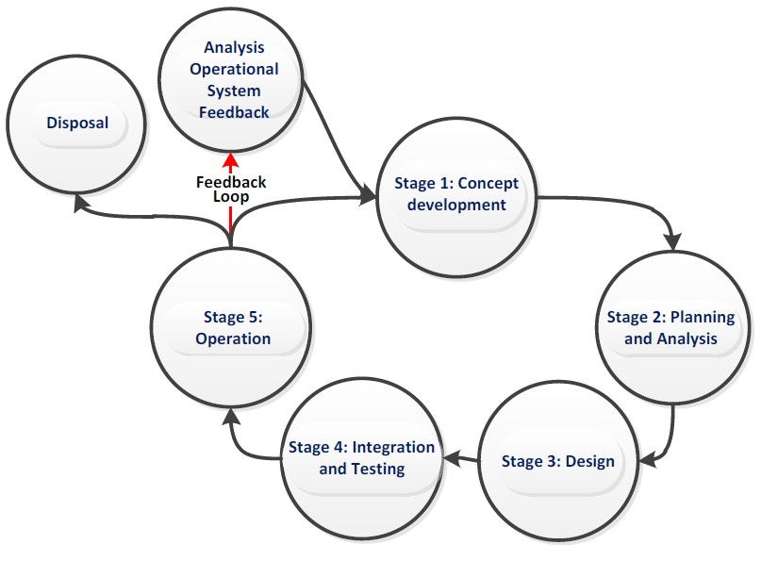

Figure 15.1 - Generic life cycle (from MSC.1/Circ.1512)
Figure 15.1 shows a typical generic life cycle with the stages recommended as a minimum for the management of the development of Product Specifications that are used with the Interoperability Catalogue:
- Analysis of operational system feedback;
- Stage 1: Concept development;
- Stage 2: Planning and analysis;
- Stage 3: Design;
- Stage 4: Integration and testing;
- Stage 5: Operation; and
- Disposal.

15.2 Support different levels of interoperation
The S-403 Interoperability Catalogue provides support for a fixed set of levels of interoperation, as defined in this document. The progression of levels is from lower to higher levels of implementation complexity and visual integration of products.

15.3 User control over loaded set
Users may load an additional product, or turn off one or more of the data products in a predefined combination.
Data from such additional products which are not mentioned in the Interoperability Catalogue are treated by the Inland ECDIS or ECS according to the priorities and viewing groups encoded in the product’s own Portrayal Catalogue (for example interleaved with layers from products controlled by the Interoperability Catalogue according to their relative drawing orders and display priorities).
Turning off a data product is treated as if the relevant datasets are not available on the system at all. For example, interoperability rules that are made inapplicable due to one of the data products in their conditions being turned off are ignored. Conversely, loading a dataset covered by an Interoperability Catalogue (with interoperability turned on) should apply the Interoperability Catalogue to the combination of the newly loaded dataset and datasets which are already loaded.

15.4 User control over interoperation level
The system should allow the user to change the interoperation level and/or pick a predefined combination by means of simple operations. Any options offered to the user must be valid in context; for example, if the user interface offers the user a choice of predefined combinations at an Interoperability Level, the listed combinations should be only those defined at that Level in the Interoperability Catalogue.
The system should minimise demands for user interaction when changing Interoperability Level or predefined combinations, subject to constraints imposed by the platform and interface. Some implications of this guidance are:
- When the Interoperability Level alone is changed and the Interoperability Catalogue contains a predefined combination of the new Level that lists the currently displayed product set, the system should apply the rules of the new Level to the product set immediately. Alternative predefined combinations for the level may be offered in an unobtrusive way.
EXAMPLE: S-125 and S-401 data are both on-screen when Level 1 is changed to Level 2, and the
Catalogue includes a “Level 2 S125+S201” predefined combination. Interleaving of S-401 and S125 features (Level 1) immediately changes to suppression of S-401 navigation aids by S-125 navigation aid features (Level 2). Optionally, a panel on the side of the graphic may display the predefined combinations defined at the new Level in the Interoperability Catalogue.
- When the predefined combination alone is changed and the Interoperability Catalogue contains the new predefined combination at the current Level, the system should apply the rules of the current Level to the new predefined combination.
EXAMPLE: The system is in Level 2 and the S125+S401 predefined combination is changed to S125+S401+S122. The system suppresses S-401 Restricted Area features of type “nature reserve” in favour of Marine Protected Areas from S-122 (assuming the Interoperability Catalogue contains such a rule).
- When the Interoperability Catalogue does not contain a predefined combination at the new Level, the user interface should provide an indication of this to the user (though not necessarily by disabling the choice or blocking the transition). Strategies for dealing with this situation are left to interface designers. For example, systems may offer to use the closest fit in the Interoperability Catalogue with any residual on-screen products as ordinary overlays.

15.5 Priority overrides for user-specified settings
Where user action amends a setting, which then conflicts with a system setting, the user setting should override the system setting.
EXAMPLE: Feature display priority set by a user should override display priority set in the Interoperability Catalogue or Portrayal Catalogue.

16 Data Encoding Guide
The data encoding guidance for S-403 Interoperability Catalogues conforms to the guidance in S-100 Part 16.

17 Normative Implementation Guidance

17.1 Reduce demand on user attention - display adjustment
Provide for the use of decluttering techniques by implementations, such as minimizing overlaps of both symbols and text, minimization of the number of colours on the display.

17.2 Reduce demands on user attention - avoid text overload
Provide for text to be shown separately from graphic display. Provide for limiting the amount of text shown both in-graphic, over-graphic, and in a separate auxiliary display.
Generally, in-line text is shorter than text from a support file, though some Specifications (for example S401) allow as many as 300 characters.
Generally speaking Interoperability Catalogue developers should review what individual Data Classification and Encoding Guides say and what Portrayal Catalogues do with text attributes, since the Product Specification developers can be expected to know which attributes can be expected to contain long text and which contain short text.

17.3 Support for novice users
Allow implementations to have "novice" modes or user interface controls, which provide shortcuts for inexperienced users.

17.4 Reduce demands on user attention - planning and monitoring modes
Planning mode can be allowed to provide more powerful information search or processing functionality at the expense of more user attention.
Route monitoring mode must support the Inland ECDIS or ECS showing the information required for monitoring while allowing bridge officers to focus on other tasks.

17.5 Interoperability and data coverage
The interoperability rules and interleaving operations described in an Interoperability Catalogue apply only in areas where the products referenced in the rule or interleaving operation have data coverage at the current display scale on the navigation system.
If data coverage for some of the products covered by an Interoperability Catalogue is absent in an area, the rules and interleaving operations referring to products which do have data coverage in the area in question will continue to apply in that area. Rules and interleaving operations referring to products which do not have data coverage in the area will not apply in the area in question.
Implementations should be capable of indicating parts of the display screen where (a) interoperability is partially applicable because some of the data products in a predefined combination do not have data coverage while others do have coverage; (b) interoperability is not applicable at all because the data products in the selected predefined combination do not have coverage (or the only coverage is that of the base S-401 layer).
NOTE (informative): Depiction and symbols for such distinguished parts of the screen is a matter for Inland ECDIS and ECS Performance Standards but an off-graphic message on the Inland ECDIS or ECS, or an adaptation of overscale warning symbology may be suitable.

17.6 Other significant information
The inclusion in Interoperability Catalogues of data products whose interoperability has not been discussed with the relevant Product Specification development team is recommended against.
There should be a dialogue between interoperability teams and Product Specification teams, so that new changes to Product Specifications are ensured to be covered by Interoperability Catalogues.
Feature Catalogue and Portrayal Catalogue development teams are stakeholders for hybrid Catalogues.
Product Specifications that are in scope of the Interoperability Catalogue should have at least ten display priority steps between display groups, in order to allow more flexibility in interleaving with other products.

17.7 Alarm and indication functionality
The rules and requirements in the applicable IMO and IEC Performance Standards for navigation systems (MSC 232(82) and IEC 61174), as amended, continue to apply when interoperability is active on the screen. Examples of these rules and requirements are:
- Requirements for which features should trigger alarms, and under what circumstances;
- The requirement to use the largest scale data available for alarms or indications of crossing the ship’s safety contour, entering a prohibited area, or other alarms or indications described in the Standards.
When S-403 interoperability is active, conditions which cause alarms and indications should be treated as follows:
- Conditions from a feature that is not displayed due to reduction in its drawing priority by interoperability should continue to function as specified by the relevant Performance Standards for
5 off-screen features or features hidden by overlays .
- Conditions from a feature that is not displayed because the feature type or instance is suppressed by an interoperability rule or operation should continue to be generated and processed according to the applicable Performance Standards, but their display should be tagged with an indicator that it was generated from a suppressed feature.
- A feature that is generated by a hybridization rule in the Interoperability Catalogue should be treated according to the highest level treatment prescribed for the input features. For example, if one of the input products to the rule triggers an alarm and the other does not, the result should be an alarm on the resultant hybrid feature.
- Conditions from a hybrid feature (item (3) above) should be treated as if they were from a normal data product and the relevant feature types from the input product(s) treated as suppressed feature types as described in item (2).
- The system should combine “spatially stacked” trigger conditions from the same or different products
6 while processing the condition, so that multiple alarms are not unnecessarily generated .
- The system should provide for user action to show or hide the alarm or indication from a suppressed feature or feature with lower drawing priority, both collectively and individually (that is, for all instances of a feature type and for particular feature instances).
5
This means alarms or indications should be generated, displayed, etc., as the standards prescribe for a feature of that type which is currently offscreen or hidden. For example, MSC 232(82) (Annex) § 11.4.2 prescribes that automatic route monitoring functions should continue when the ship is not on the display.
6
The combined effect of items 3, 4, and 5 is that an alarm on a hybrid feature in Level 3 interoperability will be accompanied by a tagged alarm on at least one of its input features.
- Conditions from a safety contour generated from S-102 data (with or without S-104 data) should be treated as conditions from a hybrid feature, with the contour from the S-401 data treated as a suppressed feature.
- The system should provide for user action to highlight the geometry of a suppressed feature, feature of lower drawing priority, or input feature to a hybrid feature, via user action. The user action should preferably be on the user interface element displaying the individual alarm or indication.
Conditions in areas outside the coverage of interoperating data products should continue to be generated and treated as specified by the governing Standards.

17.8 Interoperability in the presence of legacy data formats
The interoperability aspects of dealing with cases where S-57 and S-401 + S-1xx data are both on the navigation screen are not addressed in this Edition of S-403, pending determination of the path forward with respect to dual-fuel capability in S-100 Inland ECDIS and ECS.

17.9 Interoperability with partial data coverage
The interoperability aspects, if any, of dealing with cases where S-1xx and S-401 coverages are different are not addressed in this Edition of S-403.

17.10 Phased implementation
Implementation of interoperability is planned in two phases:
1. Phase 1: Levels 1 and 2 constructs. 2. Phase 2: Levels 3 and 4 constructs.
For this version of the Specification, only implementation of Phase 1 is envisaged. Implementation of Phase 2 is placed on hold until further notice.

18 Interoperability Catalogue Schema documentation
Detailed documentation for the XML Schema is provided in S-100 Part 16, Appendix 16-A.

19 Feature Catalogue
Levels 1 and 2 do not define Feature Catalogues. Levels 3 and 4 use an S-403 hybrid Feature Catalogue, which must be specified by developers of Level 3 or 4 Catalogues which generate hybrid features (see Parts C and D).

20 Portrayal Catalogue
Levels 1 and 2 do not define Portrayal Catalogues. Levels 3 and 4 use an S-403 hybrid Portrayal Catalogue, which must be specified by developers of Level 3 or 4 Catalogues which generate hybrid features (see Parts C and D).

Page intentionally left blank

Appendix A: Operational Contexts, Scenarios and Use Cases [Informative]
This appendix contains descriptions of operational contexts, use scenarios, and use cases for S-403 interoperability.
Section A-4 in this appendix outlines the broad types of operational contexts, limited for the present to shipboard activities. Section 5 describes which products are likely to be needed for broad categories of activities within different operational contexts. Section 6 “drills down” to operational tasks and describes which S-100 products are likely to be needed for different tasks. Section 7 describes selected hypothetical use cases in which interoperability is likely to play a role.
The contexts, activities, scenarios, and use cases in this appendix are illustrative and should not be regarded as definitive prescriptions for the implementation or use of S-403 Interoperability Catalogues in Inland ECDIS, ECS, or other systems.

A-1 References
IMO A.893(21) Guidelines for voyage planning, IMO resolution A893(21), 25 November 1999.
MSC.232(82) Revised Performance Standards for Electronic Chart Display And Information Systems (ECDIS), IMO Resolution MSC.232(82), 2006.
ICS 2016 Bridge Procedures Guide, 5th Edition, International Chamber of Shipping, London (2016).

A-2 Terms, Definitions and Abbreviations

A-2.1 Use of language
The usages specified in clause 1.3.1 (Use of language) of the “S-403” document apply to this appendix.

A-2.2 Terms and definitions

Alarm
A high-priority alert. Condition requiring immediate attention and action by the bridge team, to maintain the safe navigation of the ship.

Alert
Announcement of abnormal situations and conditions requiring attention. Alerts are divided in four priorities: emergency alarms, alarms, warnings, and cautions. An alert provides information about a defined state change in connection with information about how to announce this event in a defined way to the system and the operator.

Caution
Lowest priority of an alert. Awareness of a condition which does not warrant an alarm or warning condition, but still requires attention out of the ordinary consideration of the situation or of given information.

A-2.3 Abbreviations
OOW Officer Of the Watch
AML Additional Military Layer
ECDIS Electronic Chart Display and Information System
ECS | Electronic Charting System
FC | Feature Catalogue
GMDSS | Global Maritime Distress and Safety System
GNSS | Global Navigation Satellite System
IHO | International Hydrographic Organization/Organisation Hydrographique Internationale
IMO | International Maritime Organization
INS | Integrated Navigation System
MSC | Maritime Safety Committee (IMO)
MSI | Marine Safety Information
PC | Portrayal Catalogue
PPU | Portable Pilot Unit
PS | S-100-based Product Specification
UKC | Under-keel Clearance
UKCM | Under-keel Clearance Management
VTS | Vessel Traffic Service

A-3 Operational Contexts
In the e-Navigation concept, two scopes are defined: The ship side; and the shore side services. The S-100 concept meets the need for a Common Maritime Data Structure (CMDS). The proposed approach only focuses on the ship side. In the literature (regulation, navigation guide, study on e-navigation), navigation is defined according to two functionalities: Voyage planning; and execution of voyage plan and other officer of the watch (OOW) tasks, often summarized as “route monitoring”. The role of the future Inland ECDIS or ECS on the bridge has to be defined regarding these two functionalities. Identification of use cases on the bridge is needed to answer which S-100 products are expected for Inland ECDIS or ECS and for other bridge equipment. We are in the case of human navigation, but the approach is not in conflict with the emerging autonomous ship navigation.
According to the Bridge Procedures Guide of the International Chamber of Shipping [ICS 2016], the four stages to achieve a safe passage plan are:
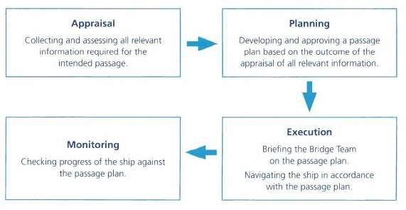

Figure A-2 - Passage planning stages (from [ICS 2016])
These four steps can be summarized in two use cases: The voyage planning; and the monitoring / execution of voyage planning, as defined in IMO regulations.

A-3.1 Voyage planning
This activity is usually performed in a relatively quiet area, on the back end of the bridge, on a chart table. It is done ahead of departure or can be conducted during long ocean passage. The officer of the watch gathers the information needed for the voyage plan from berth to berth; and may vary in format, relevance and frequency of updating. The OOW is normally available to spend a reasonable amount of time to understand information at their disposal to prepare the route: Sorting; analysis; selection of a travel planning scenario. It may require reading literature if the information is not directly understood; the OOW has the possibility to read it again, to analyse and to do a cross-reference between different information. With S-100 products, most of the information becomes georeferenced-information. Cross-reference process is more efficient.
Inland ECDIS and ECS in route planning mode is the regulated system for designing and checking the planned route. The OOW needs the following information:
Ocean routes:
- Climatological and oceanographic seasonal conditions, ocean currents, ice limits, load lines;
- Meteorological information;
- Services for weather routeing;
- Environmental protection measures;
- Ship’ routeing and reporting system, VTS;
- Navigational warnings;
- Volume of traffic likely to be encountered;
- Landfall conspicuous landmarks;
- MSI services and communications;
- Regulatory areas: Emission control areas.
Coastal routes:
- Charted features and other features for safe distance;
- Available depth of water including tidal water level information;
- UKC requirements and other limiting conditions; • Currents, tidal currents;
- Landmarks and AtoNs, availability of visual and radar fixing opportunities;
- Recommended routes and channel information, local conditions and restrictions on navigation, traffic likely to be encountered;
- Navigational warnings;
- Pilotage requirements and services, procedures (a pilotage plan is required);
- Port requirements, port facilities, procedures for port entry;
- Reporting and communication procedures;
- Details of the prospective berth and anchorages;
- Meteorological information;
- Environmental protection measures.
- Ship’ routeing and reporting system, VTS;
- MSI services and communications.
Berthing / pilotage:
- Arrival intentions including embarkation time, arrangements for cargo discharge and bunkering;
- Communications should be established with Pilot, port VTS and port authorities as appropriate;
- Pilotage plan subject of Master/pilot information exchange (MPX);
- Updates on local conditions such as weather, depth of water, tides and tidal streams, traffic conditions;
- Information on berthing arrangements including the use, characteristics and number of tugs, mooring boats, mooring arrangements and other external facilities.
IMO A.893(21) contains guidelines for voyage planning.

A-3.2 Route monitoring
This task is performed at the front of bridge, as the OOW needs to have a control view of the environment, especially when the ship is approaching harbour and entering coastal waters. The OOW normally executes the voyage planning previously defined. The voyage plan is normally stored and can be followed on an ECDIS (route monitoring mode) integrated in an INS (Integrated Navigation System). The need of synthetic, unambiguous and clear information is essential, as decision-making needs to be rapid in the face of any events that may occur (anti-collision, anti-grounding). It is necessary to reduce the number of manipulations to be carried out on the system (ECDIS) and reduce its mental workload as much as possible.
A part of the monitoring can be done with the help of the ECDIS, including monitoring of the following:
- The ship’s current position and proximity of dangers to navigation;
- The intended track (passage plan), course and speed, cross-track deviation;
- The traffic situation and the traffic density to be encountered;
- The vessel reporting requirements, completed or due;
- The environmental requirements;
- Weather conditions to be encountered including sea state and visibility;
- Uncharted navigational hazards which may be encountered.
The OOW should:
- Follow the passage plan and monitor the progress of the ship;
- Make a full appraisal of the risk of collision with other vessels;
- Identify navigational hazards such as wrecks, floating objects, ice and uncharted hazards; • Determine the risk of grounding or stranding (UKC);
- Detect and respond as appropriate to any significant change in the weather, visibility or sea state;
- Identify navigational marks;
- Perform position fixing of the ship by all appropriate means;
- Take action to avoid collision;
- Amend the passage plan:
  - Permanently (the passage planning phase is repeated). Examples of causes are weather routeing developments, change of destination, or search and rescue response.
  - For a deviation from the current plan. Examples of causes are COLREG issues, variations of weather conditions, advice received from VTS, navigational warnings, detected hazards.
- Monitor GMDSS watch keeping (radio, emergency, MSI, routine and general communications).

A-4 Product Collections for Operational Contexts
Since different operating contexts (for example, passage planning, route monitoring, etc) will involve loading different collections of data products; and since they are likely to be more or less the same for the same class of end-user, it may be useful to specify pre-defined collections or “base collections” of products which can be loaded by the user under specific conditions or for specific tasks. An Inland ECDIS or ECS would allow the user to select from a list of pre-defined product combinations instead of loading and unloading individual data products.
It is envisaged that the Inland ECDIS and ECS will allow end-users to adapt the collections or customize them by changing the load sets, selecting portrayals, changing context parameters and user settings, etc. Customized collections can be saved – thereby allowing operators, masters, and bridge officers to add to the library of pre-defined collections available on the Inland ECDIS or ECS. Either initial or customized collections can be reloaded at a later time. Users can also load additional data products, real-time information (for example, radar, AIS) or unload one or more of the default products after a pre-defined collection is loaded.
The classifications and loading in Table A-1 below are intended for illustrating interoperability use cases and not a prescription for Inland ECDIS and ECS or requirements of performance standards.
N: Not loaded.
Y: Loaded.
O: Optional (loaded or unloaded at user option).
C: Customized subset of features; for example, a subset selected by feature type, attribute value, or creation time.
“Other products” are products that are not covered by S-403 (see Table 1-1 in the “S-403 – Main” document).

Page intentionally left blank

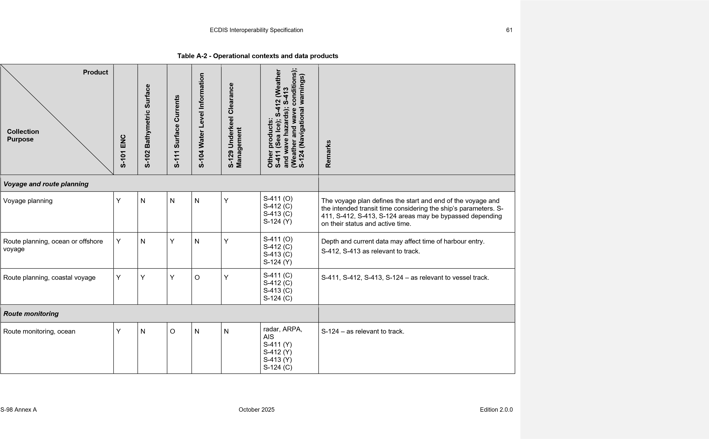
62 ECDIS Interoperability Specification
Other operations

S-403 Edition 2.0.0

63

A-5 Operational Activities and Products
This section summarizes shipboard activities and the data products likely to be needed for each.
At present this section addresses only activities in the route monitoring context.

A-5.1 Route monitoring activities
Table A-2 below summarizes the tasks related to route monitoring activity; the information needed by the OOW; and the related S-100 products.
Table A-3 - Route monitoring activities and products
Activities of OOW for route monitoring | Information | S-100 products
Follow the passage plan and monitor the progress of the Ship | Route, GNSS, chart, voyage plan | S-401
Make a full appraisal of the risk of collision with other vessels | GNSS, AIS, radar | (none)
Identify navigational hazards such as wrecks, floating objects, ice and uncharted hazards | Chart, | S-401
Determine the risk of grounding or stranding (UKC) | Chart, high density bathymetry, voyage plan | S-401  S-102  S-104
Identify navigational marks | Chart, voyage plan | S-401
Position fixing of the ship by all appropriate means | Chart, radar | S-401
Take action to avoid collision | GNSS, chart, voyage plan | S-401
Amend the passage plan permanently (the passage planning phase is repeated) - Causes: change of destination, variations of weather conditions, advice received from VTS, detected hazards | Chart | S-401  S-104
GMDSS watch keeping (radio, emergency, MSI, routine and general communications) | Chart, voyage plan | S-401

A-6 Use Cases

A-6.1 Bathymetry replaces soundings
Goal: Given an overlay certified as a suitable replacement, replace the corresponding IENC features with features from the overlay.
Actors: OOW; Inland ECDIS or ECS.
Description: S-102 (Bathymetric surface) gridded data is displayed over an IENC. The S-102 data is certified as an allowable replacement for appropriate IENC features. Depth areas, dredged areas and soundings with multi-point geometry are replaced with bathymetric surface features. Depth contours are re-computed based on S-102. Contours are computed on gridded data using an algorithm to be determined by the S-102 Project Team.

6.4 Passage / route planning
Goal: The system can be configured to display different types of information needed to plan the route for a voyage.
Actors: Passage planner (OOW, navigation officer, mate, planner in shipping company office); Inland ECDIS or ECS.
Description: IENC and bathymetric surface data are used in a back-of bridge scenario to plan the route for a voyage. The planner may turn on or off different viewing groups or sets of features from different data products so as to provide information about particular aspects of the planning problem without adding clutter by including irrelevant feature types or attributes.

A-7 Route Monitoring
Goal: The system can be configured to display different types of information needed to monitor the vessel’s route.
Actors: OOW; Inland ECDIS or ECS.
Description: This is the classic “Inland ECDIS or ECS” situation. During route monitoring in different circumstances, what are the combinations of information the boatmaster want to see on the Inland ECDIS or ECS? All the datasets? Subsets of feature types from some datasets? Sub-cases are defined in the subsections below. (Actors for the sub-cases are mentioned where they may be different from the base case.)

65

A-7.1.2 Sub-case: route monitoring
Products needed on the display are S-401 and S-102 (depths and safety contour – the latter computed from data),

A-7.1.3 Sub-case: Navigation in harbour approaches
Products needed are S-401 and S-102 (depths and safety contour).

A-7.4 Operations in narrow channels
Actors: OOW; ; Inland ECDIS or ECS.
Products needed are S-401, S-102, S-104, other data products specific to the channel.

A-7.5 Operations in congested waters
Actors: OOW; VTS controller; Inland ECDIS or ECS; VTS display.
Products needed on the display are S-401, S-102, S-104, other data products specific to the waterway if any.

A-7.6 Berthing
Actors: OOW; pilot; terminal operator; tug operator; Inland ECDIS or ECS.
A vessel approaching a berth and S-401 for harbour and berth information, S-104 for water levels, S-102 for bathymetry – all only if sufficiently large scale data is available and only in a relatively small area. Will probably have additional information too, specific to the berth and other inputs; for example, sensors for distance measurements. In fact, berthing might not use an Inland ECDIS or ECS at all, but other specialized equipment that uses only a subset of S-401 information (possibly in a specialized berthing chart) plus water level and depth data plus specialized sensors and may be partially guided from shore.

66

Page intentionally left blank

N must be replaced by 1, 2, 3, or 4, corresponding to the highest interoperability level used in the catalogue.

